**Online Food Ordering System  
Project Report**

**By**

1. **Battula Naga Prasanth Reddy**
2. **Parasa Bhavana**
3. **Sudini Venu Gopal Reddy**
4. **Taddi Tirumaleswara Sai**

**Table of Contents**

**Abstract .................................................................................................................. 1  
Table of Contents .................................................................................................... 2  
List of Figures and Tables .................................................................................... 3**

1. **Introduction ......................................................................................................... 4  
   1.1 Overview of the Project .......................................................................................... 4  
   1.2 Existing System and Limitations .......................................................................... 5  
   1.3 Purpose and Scope of the Online Food Ordering System .................................... 6  
   1.4 Importance of the Project ....................................................................................... 7**
2. **Objective ........................................................................................................... 8**
3. **Existing System .................................................................................................. 9**
4. **System Architecture Diagram ........................................................................ 10  
   4.1 System Architecture Overview ............................................................................ 10  
   4.2 Integration of AWS Services ............................................................................... 11  
   4.3 Data Flow and User Interaction .......................................................................... 12**
5. **Proposed System ............................................................................................. 13  
   5.1 Key Features of the Proposed System ................................................................ 13  
   5.2 Proposed Architecture Overview ....................................................................... 14  
   5.3 Benefits of the Proposed System ...................................................................... 15**
6. **Modules .......................................................................................................... 16  
   6.1 Administrator Module ........................................................................................... 16  
   6.2 Customer Module ................................................................................................. 17  
   6.3 Admin Module ...................................................................................................... 18  
   6.4 User Module ........................................................................................................ 19**
7. **Software Requirements .................................................................................. 20**
8. **Design .............................................................................................................. 21  
   8.1 Introduction to Design ......................................................................................... 21  
   8.2 UML Diagrams ...................................................................................................... 22  
   8.3 Use Case Diagrams ............................................................................................. 23  
   8.4 ER Diagrams ........................................................................................................ 24**
9. **Database Design ............................................................................................. 25**
10. **System Testing ............................................................................................... 26  
    10.1 Unit Testing ........................................................................................................ 26  
    10.2 Functional Testing ............................................................................................. 27  
    10.3 System Testing .................................................................................................. 28  
    10.4 Acceptance Testing ......................................................................................... 29**
11. **System Evaluation and Discussion ............................................................. 30  
    11.1 Proposed System Completion .......................................................................... 30  
    11.2 System Strengths and Limitations ................................................................... 31  
    11.3 Future Enhancements ....................................................................................... 32**
12. **Project Implementation and Testing ......................................................... 33**
13. **Conclusion ..................................................................................................... 34**
14. **References ...................................................................................................... 35**
15. **Appendices .................................................................................................... 36**

**Abstract:**

The Online Food Ordering System enhances the customer experience by offering a seamless and efficient way to order food online, overcoming the limitations of traditional queuing methods. This system increases the volume of takeaway orders, as it facilitates faster and more standardized order placements compared to in-person interactions. With an easy-to-use interface, customers can quickly browse the food menu, place orders, and track the status of their deliveries.

Leveraging cloud technologies, the system is hosted on **AWS EC2**, ensuring scalable and secure access for users. The user details, orders, and menu items are stored and managed through **AWS RDS** for reliable database performance. Customer data is securely maintained with individual accounts, which include personalized login credentials (ID and password), ensuring high levels of privacy and security. Payment for orders can be made via an online gateway or a pay-on-delivery option.

The **AWS S3** service is utilized for securely storing media files (like food images, promotional content), and **CloudWatch** is used for monitoring the performance of the platform, ensuring smooth operations. **Security Groups** and **VPC** configurations ensure a secure communication channel between services, protecting customer and order data. The **AWS CloudShell** is integrated for easy management and troubleshooting of the infrastructure.

By using this system, food service providers can streamline their operations, improve service speed, and offer customers a more convenient, secure, and interactive ordering experience. The platform’s ability to track and manage orders efficiently helps in providing better food delivery services and enhances customer satisfaction.

**Introduction**

The rapid growth of the internet and mobile technology has revolutionized the way people interact with businesses, particularly in the food service industry. One of the significant advancements in this space is the development of online food ordering systems, which have drastically improved the customer experience by providing convenience, speed, and accessibility. Traditional methods of ordering food, such as phone calls or in-person visits, often lead to inefficiencies, longer wait times, and errors in order processing. In contrast, online ordering platforms offer users the ability to browse menus, place orders, and make payments seamlessly from the comfort of their homes or on the go, thereby enhancing the overall customer experience.

This report explores the design, implementation, and benefits of an Online Food Ordering System built using cloud-based technologies. The system leverages **Amazon Web Services (AWS)**, including EC2, RDS, S3, CloudWatch, and Security Groups, to provide a scalable, secure, and efficient platform for both customers and service providers. The use of these advanced AWS tools ensures that the system is highly available, secure, and capable of handling large volumes of data and user requests simultaneously, making it ideal for both small and large-scale food delivery services.

The primary goal of this system is to streamline the food ordering process, reduce human error, and enhance customer satisfaction by offering a user-friendly interface, real-time order tracking, and a secure payment gateway. Additionally, the system prioritizes data privacy and security, ensuring that sensitive user information, such as personal details and payment data, is stored securely and transmitted over encrypted channels.

This report will cover the architecture of the system, the integration of AWS services, the features of the food ordering platform, and the expected outcomes for businesses and customers. By adopting such an online ordering system, food service providers can significantly improve operational efficiency, reduce costs, and offer a superior service experience to their customers. The next sections will delve into the specific components and functionality of the system, followed by a discussion on the impact of these technologies on the food service industry.

**Objective**

The primary objective of this Online Food Ordering System is to enhance the food ordering process by offering customers a convenient, efficient, and secure platform to place orders and make payments online. Specifically, the objectives of the system include:

1. **Streamlining the Ordering Process**: To provide a user-friendly interface where customers can easily browse through the food menu, select desired items, and place orders with a simple click, eliminating the need for traditional queuing systems and reducing wait times.
2. **Ensuring Data Security and Privacy**: To ensure that customer information, including personal details and payment data, is securely stored and transmitted. The system aims to comply with industry-standard security practices, utilizing encryption and secure authentication methods to maintain user privacy.
3. **Improving Operational Efficiency**: To help food service providers manage orders more effectively by automating key processes such as order tracking, payment processing, and inventory management. This results in a smoother, faster workflow and reduced chances of errors in order handling.
4. **Supporting Scalable Growth**: To leverage **AWS cloud infrastructure** (EC2, RDS, S3, CloudWatch, and Security Groups) to support a scalable solution capable of handling increasing traffic and data loads. The system is designed to grow alongside business needs, ensuring continued performance and reliability as demand rises.
5. **Providing Real-Time Order Tracking**: To enable customers to track their orders in real-time, from the moment they place an order to the point of delivery, improving customer satisfaction and communication.
6. **Offering Secure Payment Options**: To integrate multiple payment methods, including online payment gateways and pay-on-delivery options, allowing customers flexibility in how they complete their transactions.
7. **Enhancing Customer Satisfaction**: To improve the overall user experience by providing a seamless, intuitive, and personalized ordering process that encourages repeat business and customer loyalty.

This system seeks to not only meet the needs of customers but also empower food service providers by offering a platform that enhances operational efficiency, scalability, and customer service.

**Existing System**

In the existing food ordering system, customers are required to visit restaurants in person to inquire about available food items. This traditional process involves physical menus and face-to-face interactions with restaurant staff, which can often be time-consuming and inefficient. Customers must then place their orders and pay in advance, which adds another layer of inconvenience, especially for those who prefer the flexibility of ordering from home or on the go.

The current method is heavily reliant on manual work, both for the customer and the restaurant staff. Restaurant employees must manually track customer orders, which can lead to human errors, miscommunication, and delays in service. Furthermore, maintaining critical information, such as customer details, order history, and inventory, is done through paper records or basic digital files. This approach is not only prone to errors but also carries significant risks, such as data loss, security breaches, and inefficiencies in updating and accessing information.

Additionally, this system lacks the ability to scale, making it difficult for restaurants to manage large volumes of orders or expand their services to a broader customer base. As a result, the overall customer experience is often compromised, leading to longer wait times, miscommunication, and dissatisfaction.

Thus, the existing system falls short of meeting the modern needs of both customers and food service providers. It requires a significant amount of time, manual effort, and risk management, which hinders efficiency and growth. A more efficient, automated, and secure system is necessary to address these challenges and improve the overall ordering process.

**System Architecture Diagram**

The architecture of the **Online Food Ordering System** is designed using cloud-based technologies to ensure scalability, security, and efficient performance. This section provides an overview of the system components and their interactions within the cloud infrastructure.

**System Architecture Overview**

The system is built on **Amazon Web Services (AWS)** and consists of the following components:

* **Amazon EC2**: Hosts the web application and processes user requests.
* **Amazon RDS**: Stores user and order data in a secure relational database.
* **Amazon S3**: Stores static files such as food images, menus, and promotional content.
* **Amazon CloudWatch**: Monitors the system's performance and generates alerts for any issues.
* **Security Groups and VPC**: Manages secure communication between different services in the cloud.

**AD DIAGRAM**

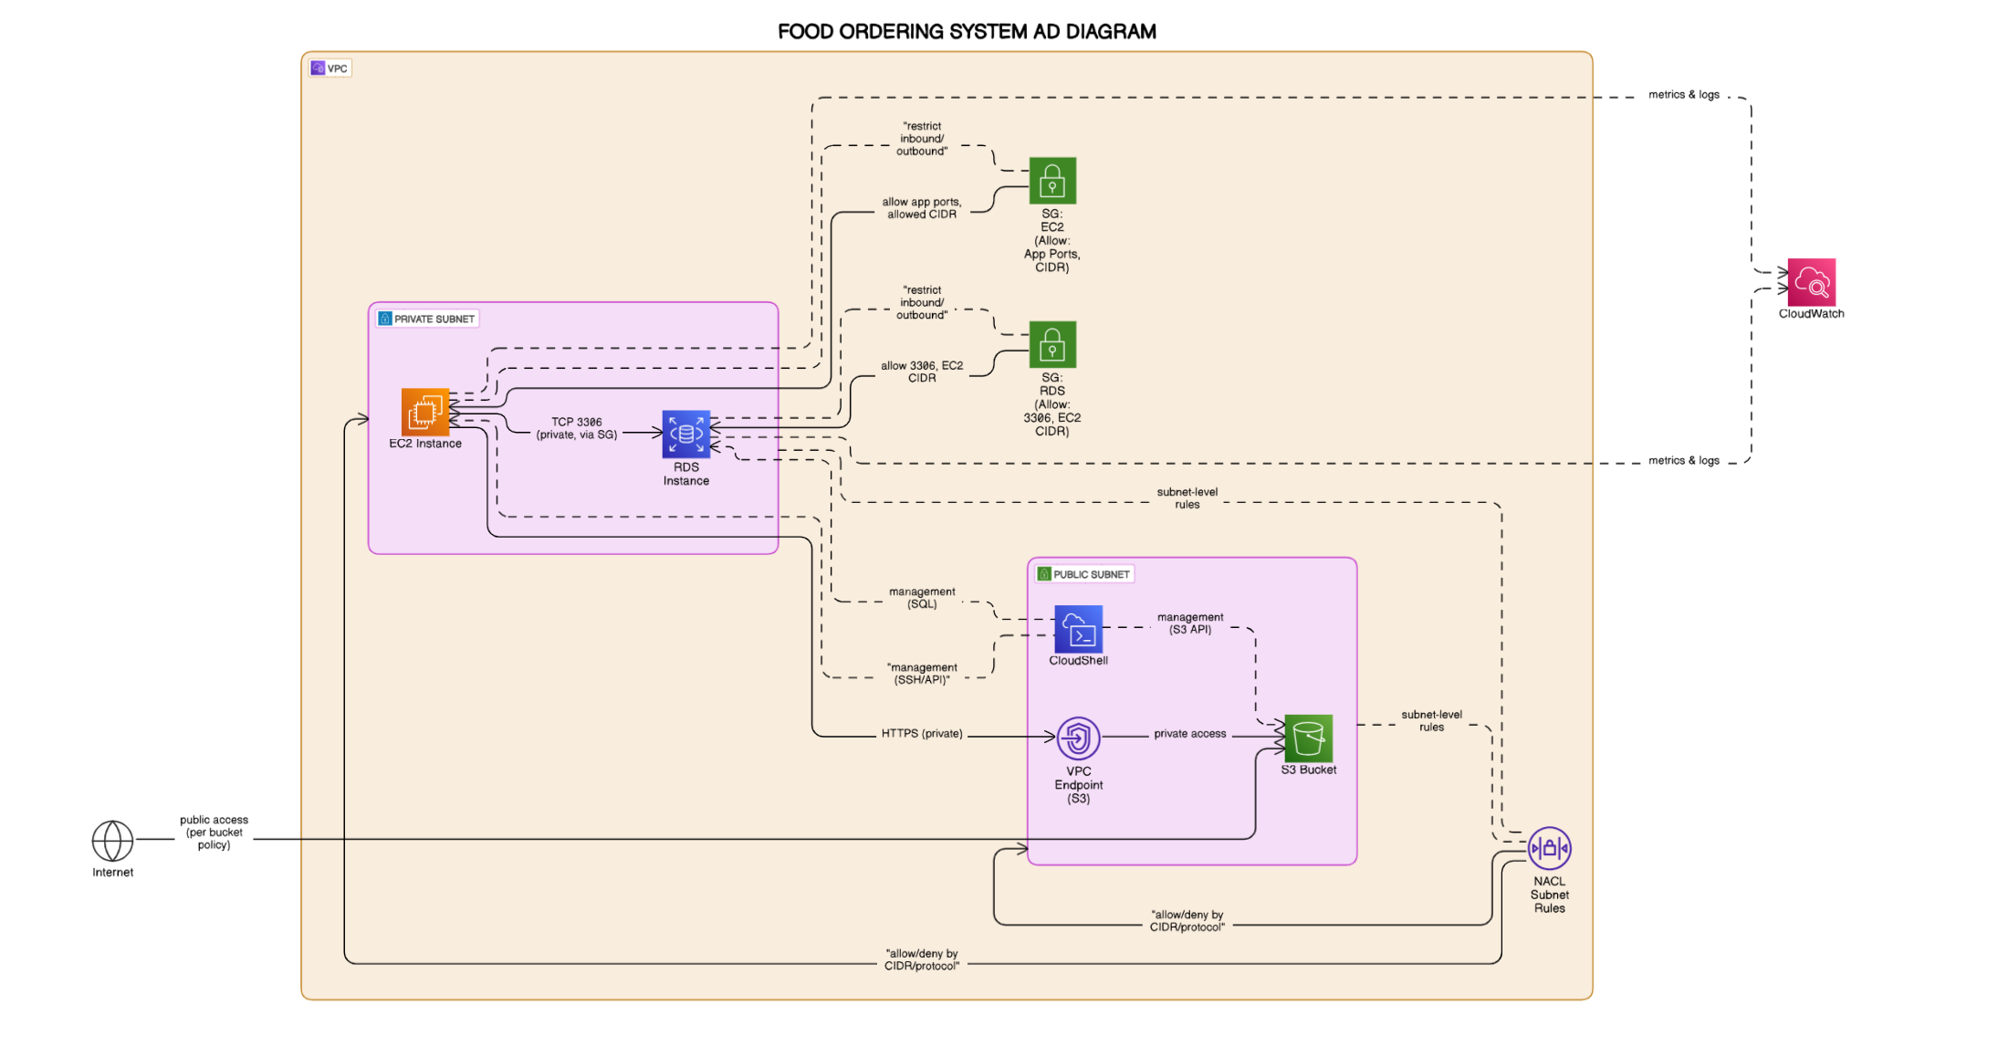

This architecture diagram illustrates how the system components are integrated to provide an efficient and seamless food ordering experience. The diagram includes the following relationships:

1. **User Interaction**: The user accesses the platform via the web interface hosted on **EC2** instances.
2. **Order Processing**: Once the user places an order, the data is stored in the **RDS** database.
3. **Media Management**: Food images and menu data are stored in **Amazon S3**.
4. **System Monitoring**: **CloudWatch** continuously monitors the performance of **EC2** and **RDS** instances.
5. **Security**: **Security Groups** and **VPC** ensure that each service communicates securely within the cloud infrastructure.

**Diagram Description**

The following steps are represented in the architecture diagram:

1. **User submits order** → EC2 Instance (handles order processing).
2. **Order data stored** → Amazon RDS (Relational Database Service).
3. **Menu and media files stored** → Amazon S3.
4. **Performance monitoring** → Amazon CloudWatch.

**Proposed System:**

**Proposed System**

The **Proposed System** for the Online Food Ordering platform aims to revolutionize the way customers interact with food service providers by offering an easy-to-use, secure, and scalable solution. Unlike the existing manual system, the proposed solution integrates modern cloud technologies and provides numerous advantages, including efficiency, automation, and real-time updates. This system is designed to improve customer satisfaction, streamline operations, and increase scalability for food service providers.

**Key Features of the Proposed System**

1. **User-Friendly Interface**  
   The system is designed with a simple and intuitive interface, allowing customers to easily browse through a digital menu, select food items, and place orders in just a few clicks. The menu will be interactive, offering images and descriptions of food items to enhance the user experience.
2. **Online Ordering and Payment Options**  
   Customers can place their orders online and choose from multiple payment methods, including online payment gateways and pay-on-delivery options. The system will integrate with secure payment providers, ensuring that all transactions are processed safely.
3. **Real-Time Order Tracking**  
   Customers can track the status of their orders in real-time, from the moment the order is placed to its delivery. Notifications will be sent to users at various stages, such as when the order is confirmed, prepared, and dispatched.
4. **Scalability and Performance**  
   The system is built on AWS infrastructure, allowing it to handle high traffic and large volumes of orders. As the number of users and orders increases, the system can scale efficiently to accommodate the growing demand, ensuring consistent performance.
5. **Data Security and Privacy**  
   The proposed system employs robust security measures to protect sensitive user data. User information, such as personal details and payment data, will be stored securely in encrypted databases. Secure login methods will ensure that only authorized users can access their accounts.
6. **Automation and Efficiency**  
   The system automates critical processes such as order tracking, payment processing, and inventory management. This reduces the need for manual intervention, minimizes errors, and streamlines the entire workflow.
7. **Admin Dashboard**  
   An admin dashboard will be available for restaurant managers to track orders, manage menus, and access customer data. This allows restaurant owners to monitor performance, make adjustments to the menu, and ensure that orders are being processed efficiently.

**Proposed Architecture Overview**

The proposed system architecture utilizes AWS cloud services to ensure that it is secure, scalable, and high-performing:

* **Amazon EC2**: Hosts the web application and processes user requests.
* **Amazon RDS**: Stores user data and order information in a relational database for easy management and querying.
* **Amazon S3**: Stores food images, menus, and other media files securely, which can be accessed by the EC2 instances to display to customers.
* **Amazon CloudWatch**: Provides monitoring and logging for performance tracking and alerting.
* **AWS Security Groups and VPC**: Secures communication between various components of the system by controlling traffic and enforcing network security.
* **Payment Gateway Integration**: Securely processes customer payments.

**Benefits of the Proposed System**

1. **Improved Customer Experience**: The online platform offers a convenient and fast way for customers to order food. Real-time order tracking and a secure payment process ensure a seamless experience.
2. **Increased Efficiency**: Automation of key processes, such as order tracking, payment, and inventory management, reduces manual labor, decreases the chance for errors, and improves operational efficiency.
3. **Better Data Management**: Storing customer and order data in a secure cloud database ensures that the information is easily accessible, accurate, and protected. Data backup and recovery are handled by AWS services to ensure minimal risk.
4. **Scalability**: The system can easily scale to accommodate increased traffic, allowing food service providers to grow their business without worrying about server limitations.
5. **Cost-Effective**: The system is hosted on AWS, reducing the need for expensive on-premise infrastructure. AWS services are cost-effective and billed on a pay-as-you-go basis, meaning that you only pay for what you use.
6. **Security**: With encryption, secure user authentication, and compliance with security best practices, the system ensures that user data is protected against breaches.

**Modules:**

**Administrator Module**

The **Administrator** can manage all aspects of the system, including viewing and editing customer details, managing food categories, and overseeing orders. The functionalities include:

* **Create Food Category**: The admin can create new food categories.
* **Manage Food Categories**: The admin can update, delete, or modify food categories.
* **Add Food Item**: The admin can add new food items to the menu.
* **Manage Food Items**: The admin can update, delete, or modify existing food items.
* **Manage User Orders**: The admin can view and manage all customer orders.

**Customer Module**

The **Customer** module provides the following functionalities:

* **View Product List**: Customers can browse through the available food items.
* **Register**: Customers can create an account to start ordering.
* **Place Orders**: Customers can select food items and place orders.

**Admin Module**

1. **Dashboard**:
   * In this section, the admin can view a summary of key metrics, including:
     + Total orders
     + Orders that are not confirmed
     + Confirmed orders
     + Total food being prepared
     + Total food for pickup
     + Total food delivered
     + Total cancelled orders
     + Total users
2. **Registered Users (Reg Users)**:
   * The admin can manage registered users by viewing and updating their details.
3. **Food Categories**:
   * The admin can manage food categories by adding, updating, or deleting them.
4. **Food Menu**:
   * The admin can manage the food menu by adding, updating, or deleting items.
5. **Orders**:
   * The admin can view detailed food order information and update the order status based on the current order progress.
6. **Search Order**:
   * The admin can search for specific orders using the order number.
7. **Reports**:
   * The admin can generate reports on orders, sales, and order counts for specific date ranges.

Additionally, the admin has the ability to:

* **Update Profile**: Admin can update personal profile details.
* **Change Password**: Admin can change their password.
* **Recover Password**: Admin can recover or reset the password if forgotten.

**User Module**

1. **Food Menu**:
   * Users can browse the food menu to view available items at the restaurant.
2. **My Account**:
   * Users can view and update their profiles and change their password. They can also log out of their accounts.
3. **My Orders**:
   * Users can view their order history after logging into their account.
4. **Cart**:
   * Users can add food items to their cart before proceeding to place an order.
5. **Invoice and Order Cancellation**:
   * Users can download their order invoice and have the option to cancel their order if they choose.

**Homepage Information**

The **Homepage** provides functionality for both registered and guest users:

* **Guest Users**:
  + Guest users (those who are not registered) can view the restaurant’s food menu and search for food by name.
  + Guest users can also sign up to create an account or log in if they are already registered.
  + Guest users can track their orders without needing to log in.

**Software Requirements**

The following are the key software requirements necessary to successfully develop, deploy, and maintain the **Online Food Ordering System**:

**1. Operating System**

* **Ubuntu 20.04**
  + The system will be developed and deployed on **Ubuntu 20.04**, providing a stable and efficient environment for backend development and server management.

**2. Web Server**

* **Apache** / **Nginx**
  + **Apache** or **Nginx** will be used to host the web application on the server. These web servers handle HTTP requests and ensure the web application runs efficiently.

**3. Backend Programming Language**

* **PHP**
  + PHP is used for backend development, as it is widely used in web development and offers strong support for database connectivity, security, and session management.

**4. Frontend Programming Languages**

* **HTML5**
  + HTML5 will be used to structure content on the web pages, including forms, links, images, and multimedia content.
* **CSS3**
  + CSS3 will be used to style the web pages and provide a responsive design for optimal viewing on various devices.
* **JavaScript**
  + JavaScript will be used for dynamic content loading, user interaction, and asynchronous requests (AJAX). It can be paired with front-end frameworks like **React.js** for a more interactive experience.

**5. Database Management System (DBMS)**

* **MySQL** / **PostgreSQL**
  + **MySQL** or **PostgreSQL** will be used as the relational database management system (RDBMS) to store and manage customer data, orders, food items, and transactions. These databases are chosen for their scalability and support for complex queries.

**6. Cloud Platform**

* **Amazon Web Services (AWS)**
  + **AWS EC2**: Used to host the web application, providing scalability and flexibility.
  + **AWS RDS**: For secure and scalable storage of customer and order data.
  + **AWS S3**: For storage of static files, such as images and menus.
  + **AWS CloudWatch**: For monitoring system performance and generating alerts.

**7. Development Tools**

* **IDE/Code Editor**: **Visual Studio Code** / **PHPStorm** / **Sublime Text**
  + A code editor like **Visual Studio Code** or **PHPStorm** is necessary for writing, editing, and debugging the code.
* **XAMPP** / **MAMP**
  + For local development, **XAMPP** or **MAMP** can be used to set up a local server environment with Apache, PHP, and MySQL support.

**8. Frameworks and Libraries**

* **PHP Framework**: **Laravel** / **CodeIgniter**
  + **Laravel** or **CodeIgniter** can be used as a PHP framework for building a robust, secure, and scalable application.
* **JavaScript Framework**: **React.js** / **Vue.js**
  + **React.js** or **Vue.js** can be used for building dynamic and interactive user interfaces, making the frontend more responsive and easier to maintain.

**9. Testing Tools**

* **PHPUnit**
  + **PHPUnit** will be used for unit testing the PHP code to ensure that each component of the backend system functions correctly.
* **Selenium**
  + **Selenium** can be used for automated UI testing, ensuring that the web application works as expected in different browsers and environments.
* **Postman**
  + **Postman** will be used for testing and managing API endpoints, particularly for order management and backend integrations.

**10. Security Tools**

* **SSL/TLS** (for HTTPS)
  + An SSL certificate will be used to enable secure HTTPS communication, ensuring data encryption between the client and server.

**11. Deployment and Hosting**

* **AWS EC2** / **DigitalOcean**
  + The web application will be hosted on **AWS EC2** for scalability and performance. Alternatively, **DigitalOcean** can also be used for hosting the application on cloud servers.
* **AWS RDS**
  + **AWS RDS** will host the database to ensure reliability, high availability, and seamless scaling.

**Design**

**INTRODUCTION:**

Design is the first step in the development phase for any techniques and principles for the purpose of defining a device, a process or system in sufficient detail to permit its physical realization.

Once the software requirements have been analyzed and specified the software design involves three technical activities - design, coding, implementation and testing that are required to build and verify the software.

The design activities are of main importance in this phase, because in this activity, decisions ultimately affecting the success of the software implementation and its ease of maintenance are made. These decisions have the final bearing upon reliability and maintainability of the system. Design is the only way to accurately translate the customer’s requirements into finished software or a system.

Design is the place where quality is fostered in development. Software design is a process through which requirements are translated into a representation of software. Software design is conducted in two steps. Preliminary design is concerned with the transformation of requirements into data.

UML Diagrams:

Actor:  
A coherent set of roles that users of use cases play when interacting with the use `cases.

Use case:

A description of sequence of actions, including variants, that a system performs that yields an observable result of value of an actor.



UML stands for Unified Modeling Language. UML is a language for specifying, visualizing and documenting the system. This is the step while developing any product after analysis. The goal from this is to produce a model of the entities involved in the project which later need to be built. The representation of the entities that are to be used in the product being developed need to be designed.

There are various kinds of methods in software design:

They are as follows:

* Use case Diagram
* Sequence Diagram
* Collaboration Diagram
* Activity Diagram
* State chat Diagram

**USECASE DIAGRAMS:**

Use case diagrams model behavior within a system and helps the developers understand of what the user require. The stick man represents what’s called an actor.

Use case diagram can be useful for getting an overall view of the system and clarifying who can do and more importantly what they can’t do.

Use case diagram consists of use cases and actors and shows the interaction between the use case and actors.

* The purpose is to show the interactions between the use case and actor.
* To represent the system requirements from user’s perspective.
* An actor could be the end-user of the system or an external system.

**USECASE DIAGRAM:**

A Use case is a description of set of sequence of actions. Graphically it is rendered as an ellipse with solid line including only its name. Use case diagram is a behavioral diagram that shows a set of use cases and actors and their relationship. It is an association between the use cases and actors. An actor represents a real-world object. Primary Actor – Sender, Secondary Actor Receiver.

**Admin Use Case Diagram:**

**Admin**

**User Use Case Diagram:**

**User**

**E-R Diagrams:**

The Entity-Relationship (ER) model was originally proposed by Peter in 1976 [Chen76] as a way to unify the network and relational database views. Simply stated the ER model is a conceptual data model that views the real world as entities and relationships. A basic component of the model is the Entity-Relationship diagram which is used to visually represents data objects. Since Chen wrote his paper the model has been extended and today it is commonly used for database design For the database designer, the utility of the ER model is:

* it maps well to the relational model. The constructs used in the ER model can easily be transformed into relational tables.
* it is simple and easy to understand with a minimum of training. Therefore, the model can be used by the database designer to communicate the design to the end user.
* In addition, the model can be used as a design plan by the database developer to implement a data model in a specific database management software.

## Connectivity and Cardinality

The basic types of connectivity for relations are: one-to-one, one-to-many, and many-to-many. A *one-to-one* (1:1) relationship is when at most one instance of a entity A is associated with one instance of entity B. For example, "employees in the company are each assigned their own office. For each employee there exists a unique office and for each office there exists a unique employee.

A *one-to-many* (1:N) relationships is when for one instance of entity A, there are zero, one, or many instances of entity B, but for one instance of entity B, there is only one instance of entity A. An example of a 1:N relationships is

a department has many employees each employee is assigned to one department

A *many-to-many* (M:N) relationship, sometimes called non-specific, is when for one instance of entity A, there are zero, one, or many instances of entity B and for one instance of entity B there are zero, one, or many instances of entity A. The connectivity of a relationship describes the mapping of associated

## ER Notation

There is no standard for representing data objects in ER diagrams. Each modeling methodology uses its own notation. The original notation used by Chen is widely used in academics texts and journals but rarely seen in either CASE tools or publications by non-academics. Today, there are a number of notations used; among the more common are Bachman, crow's foot, and IDEFIX.

All notational styles represent entities as rectangular boxes and relationships as lines connecting boxes. Each style uses a special set of symbols to represent the cardinality of a connection. The notation used in this document is from Martin. The symbols used for the basic ER constructs are:

* **Entities** are represented by labeled rectangles. The label is the name of the entity. Entity names should be singular nouns.
* **Relationships** are represented by a solid line connecting two entities. The name of the relationship is written above the line. Relationship names should be verbs
* **Attributes**, when included, are listed inside the entity rectangle. Attributes which are identifiers are underlined. Attribute names should be singular nouns.
* **Cardinality** of many is represented by a line ending in a crow's foot. If the crow's foot is omitted, the cardinality is one.
* **Existence** is represented by placing a circle or a perpendicular bar on the line. Mandatory existence is shown by the bar (looks like a 1) next to the entity for an instance is required. Optional existence is shown by placing a circle next to the entity that is optional

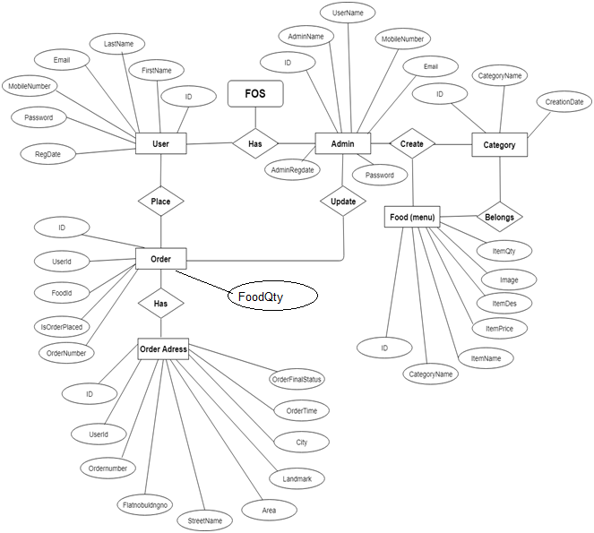

**Database Design**

The data in the system has to be stored and retrieved from database. Designing the database is part of system design. Data elements and data structures to be stored have been identified at analysis stage. They are structured and put together to design the data storage and retrieval system.

A database is a collection of interrelated data stored with minimum redundancy to serve many users quickly and efficiently. The general objective is to make database access easy, quick, inexpensive and flexible for the user. Relationships are established between the data items and unnecessary data items are removed. Normalization is done to get an internal consistency of data and to have minimum redundancy and maximum stability. This ensures minimizing data storage required, minimizing chances of data inconsistencies and optimizing for updates. The MySQL database has been chosen for developing the relevant databases.

**Food Ordering System (FOS) contains 7 MySQL tables:**

**tbladmin :** This table store the admin login details

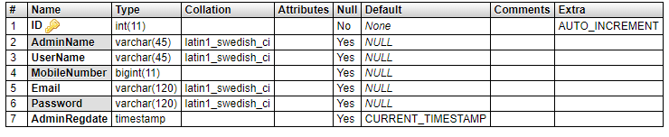

**tblcategory :** This table stores the food category

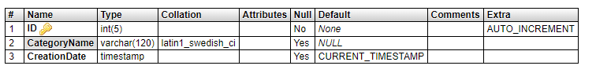

**tblfood :** This tables stores the food details (used for food menu)

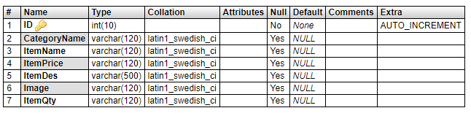

**tblfoodtracking :** This table stores the food tacking data.

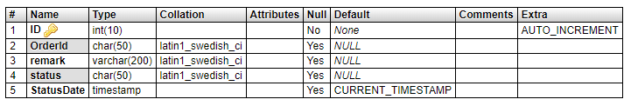

**tblorderaddresses :** This table stores the delivery address.

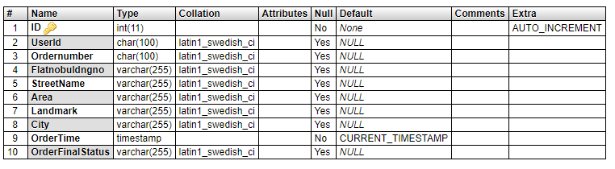

**tblorders:** This table store the food order details.

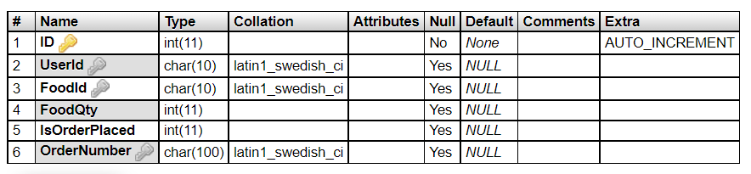

**tbluser :** This table store the user details.

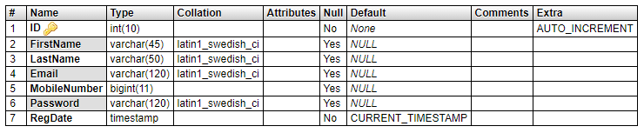

**Tables Relationship Diagram**

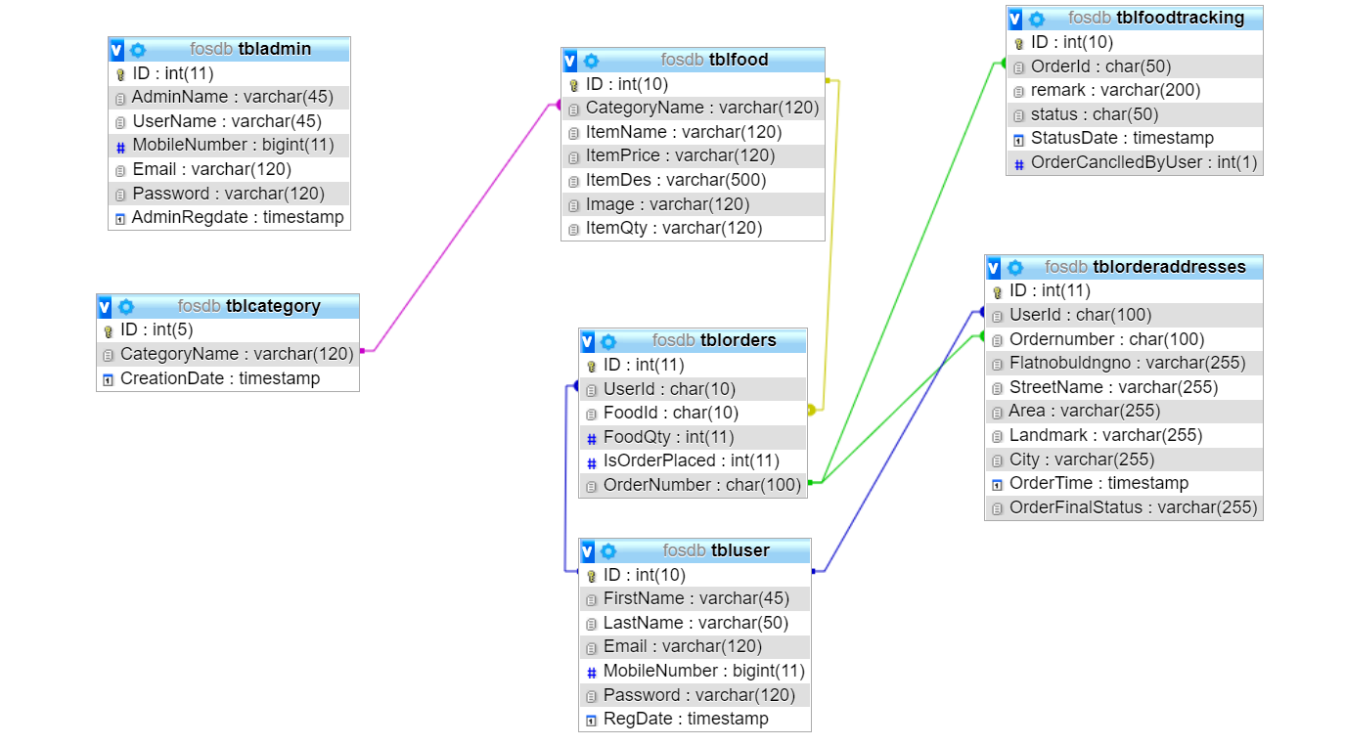

**SYSTEM TESTING**

**Project Implementation & Testing**

At the end of the system design, it is the beginning for the actual coding to develop the proposed system. During development phase, the table structure of the database will be first built in order to provide a suitable data types that suit the system back end development, system connection and data transfer. Next, the computer side client program will be developed and follow by will be the web services that allow mobile phone client program to communicate with the server and lastly mobile phone side client program will be developed. In testing phase, several test cases will be carrying out to test the system in order to determine the system reliability and system accuracy. According to the test cases, a system testing report will be generated for further review to figure out the system weaknesses and made improvement accordingly. In the deployment phase, several training will be provided for the particular restaurant staff such as how to operate the system, the procedure of handling different event and several instruction that need to be follow when operating the system.

**Implementation Issues & Challenges**

During the system implementation phase, several challenges need to be confront because it involve end users to test the production system with various situation. The possible challenges may face are as following:

**User without background**

The users are required to have basic knowledge of how to operate a computer system and android mobile phone in order to use the system. This will be difficulty to give training to the user as the basic knowledge information can be obtained from internet easily.

**The screen size of different device**

This would be one of the issue that will encounter while implementing the system. Because user are able to download the mobile application from the official website and use it as a client device to place order. Therefore, if the user device screens size are too small or too big. The content and interface of the application may not consistence.

**Server performance**

During real time system implementation, three would be a huge number of client that access to the server at the same time. Therefore, it may slow down the connection and performances of the system and even causes the server down if the issue goes beyond the level of acceptance.

**Development Tools**

**Database Environment**

The proposed system will need a database system to support in order to store the huge amount of data. MySQL database system will be chosen to support the proposed system because it is well-known open source relational database management system. Other than that, MySQL database system provides software developer with a client program with easy understanding graphical user interface that can communicate to the MySQL database server named as MySQL Workbench 6.3 CE. By doing so, software developer can interact with the database system with the user friendliness client program and without using the command prompt, at the end it may speed up the development progress.

**Web Technology**

The proposed system is a cross platform system, which include Windows desktop client and Android mobile phone client. Therefore, it require to implement web services in order to support the Android mobile phone client device to fetch data from the database server and store data back to the database server. In this project, WampServer is used to support the issue that mention earlier. WampServer is a Windows web development environment that built-in comes together with the Apache, PHP and MySQL database. Furthermore, PHP will be the programming language that used to create the web services that store in the server and it is able to call by the Android mobile phone client to perform particular task.

**System Platform**

The project is a cross platform based system which includes Windows desktop client device and Android mobile phone client device in order to operate the proposed system

Therefore, IOS mobile phone client device will not compatible with the proposed system.

**Project Management Tool**

For the rule of thumb to develop a system, it requires to have an intact system planning which serve as a guide line during the development phases. Microsoft Project is a project management software program and it has been used in the project to design the system planning, project timeline, managing of resources, tracking development progress and etc.

**Visual Paradigm Community Edition**

In this project, Visual Paradigm software has been used to create document for several system planning diagram such as Use-Case diagram, Activity diagram, Class diagram and etc. By doing so, software developer are able to visualize the system communicate information much more concisely and clearly.

**Test Plan**

After the system has been developed, it will move to system testing phase. In system testing phase, the developed system is required to install on appropriate devices for testing purpose. After the system installation has been completed, the system testing task will be performed by different roles of user such as manager role and staff role. The purpose of system testing is to identify and determine the degree of system stability. At the same time, it is given an opportunity for developer to figure out error or bug that has not been raise and encounter during the system development phase. Those error or bug that has been found during the system testing activities will be solved before the system release. Each and every testing before system testing phases is actually tested by the system developer itself. Therefore, it might cause some biases toward the testing due to the system developer have knowledge about the system software logics and lead the result to be inappropriate. There are four types of testing that will be used to test the developed system which includes unit testing, integration testing, system testing and acceptance testing.

**Unit Testing**

First of all, unit testing will be the first testing method that used to test the developed system. It consists of testing activities that test the system module by module which has not been integrated as a whole. By doing unit testing, developer are able to identify error and bug easily since it is finding the error and bug through a unit part of the system rather than finding error through the complete system. In addition, developer will test the unit part of the system with the validation and the correctness of data value. Valid and invalid input will be entering to test and ensure the system processes perform with an expected result.

**Functional Testing**

After conducted the unit testing, functional testing will begin to test the developed system. Functional testing is performed to verify that the system application processes that perform and functioning appropriately according to the design specifications. In functional testing, the core system application functions will be tested with several test cases in order to ensure that the entire system functioning as a whole and perform task that with the expected results.

**Testing**

System testing of the software and hardware is a testing conducted on a system which is complete, integrated system that works as a whole. System testing is a critical testing procedure that must be conducted by software developer before the system released. During system testing it can evaluate the system’s compliance with its specified requirements according to the system design. Furthermore, several testing activities in system testing test not only the design of the system, but also the behavior and the believed expectations result from the customer. In addition, various complex test cases that used to test the system are according to the business process requirements which are collected from the user. Meanwhile, errors or bugs that detected during the testing is required software developer look into it from the initial step of the business process to the end of the process to ensure it have expected result in order to solve the errors or bugs to determine the degree of system stability.

**Acceptance Testing**

Last but not lease, acceptance testing also known as user acceptance testing would be the final testing procedure that perform to test the developed software system. In acceptance testing, the testing activities are different compare to the testing activities that mentioned previously because the tester that tests the system will be the final user which do not have knowledge about the system logic. If the final user encountered an error while using the system, system developer are required to maintain the system as soon as possible and release a new patch for the existing system to recover the error. Meanwhile, final user will use the system that visualized as to support their real business routine operation, therefore software support team are required to stand by to provide technical support while final user need any help or support that regarding the system. If there is no errors detected by the final user while using the system for a long period, the development job of developer is consider as complete and the system will be a final system product.

**SYSTEM EVALUATE AND DISCUSSION**

**Proposed System Completion**

The proposed system is designed and developed to solve all the problem statements which are stated in chapter one of this report. First of all, the developed system provides a feature that is able to solve the problem of difficulties in food order ticket tracking and achieve the project objective of prevention of food serves not in sequence. By using the system, it allow staff to placed order ticket through using the system and the system will automatically queue the food order information according to the first come first serve basis and kitchen staff is able to follow the food queue to serve customer accordingly. It also eliminates all the manual processes that involve in the traditional method of delivering food order ticket. In addition, the developed system allows manager to update all the food information as it is needed. This features helps restaurant to eliminate duplicated physical menu card which contain misleading information and also allow staff and customer to view the latest updated food menu information through using the system. By doing so, it helps restaurant to solve the problem which regarding difficulties in updating menu card information, difficulties in providing appropriate updated food information and the potential of increase cost of operation as the system will automatically refresh all the updated information that is edited by manager. Furthermore, the project objective which regarding provides convenience for both employees and consumers has been achieved because the system allow consumer to view all the updated information through the mobile phone client devices and it reduce the number of manual work which restaurant staff need to be performed. Last but not lease, the project objective of assisting restaurant to plan ahead has been achieved due to the system allow manager to generate several types of report in order to assist the restaurant to plan ahead. By analyzing the generated report, manager is able to carry out a planning for the next business routine of the restaurant in order to improve the restaurant operation efficiency. In a nutshell, the system has fulfilled all significant outcomes that according to all the problem statements and project objectives that are stated.

**System Strength and Limitation**

**System Strength**

The system provide customer with good dine in experience as it allow customer to view food information and place order through using the mobile phone device. The mobile application also provides ease of use because it has easy understandable graphic user interface and minimal instruction to follow while place order through the application. Next, it helps restaurant staff to serve their value customer in minimal delay. Furthermore, the system can be implemented with low cost and is affordable for most of the small medium enterprise restaurant, because the hardware requirements are not required to be high end powerful in order to support the system. Lastly, server and client are communicating within the restaurant which is intranet therefore it does not need to have internet access.

**System Limitation**

The system is not compatible with IOS mobile devices as the mobile application is developed in Android environment. Therefore, for IOS mobile phone user may not able to install the application in their mobile phone and experience the system. Meanwhile, the restaurant has prepared some Android mobile devices which are used to resolve the issue that mention above. Next, due to the mobile phone client devices are required to connect to the wireless intranet in order to communicate with the server. It is very important to identify a suitable location that used to install and set up the wireless access point in order to ensure the wireless signal coverage is able to reach the entire restaurant area.

**Future Enhancement**

The system can implement a feature which is real time notification from the mobile phone application to the service desk. This feature enable customer to request customer service through using the mobile application rather than verbally call restaurant staff to approach them. In addition, the mobile application also can implement a feature that allow customer to update the food serve status. For example, customers fine dining at the restaurant they can request the food to be serve through using the mobile application and if the customer finish the main course and feeling full, the customer may request do not serve the following food through using the mobile application. Last but not lease, the mobile application may implement some mini game that is able to entertain customers while they are waiting for the food to be served.

**Project Output Screens**

**Output Screen of User Side**

**Food Menu**

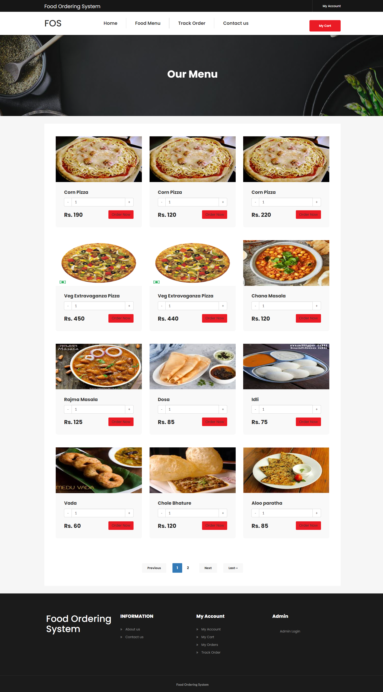

**About Us**

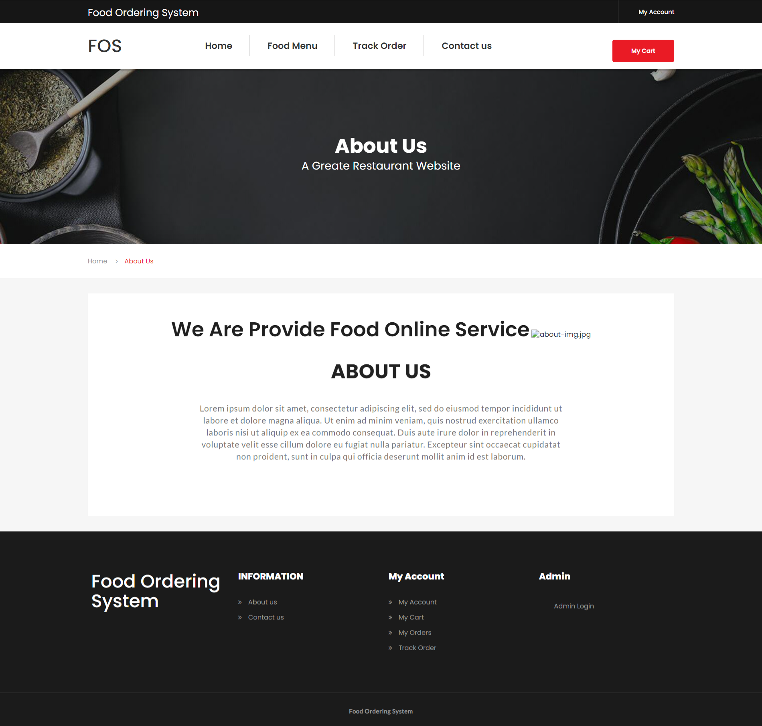

**Contact Us**

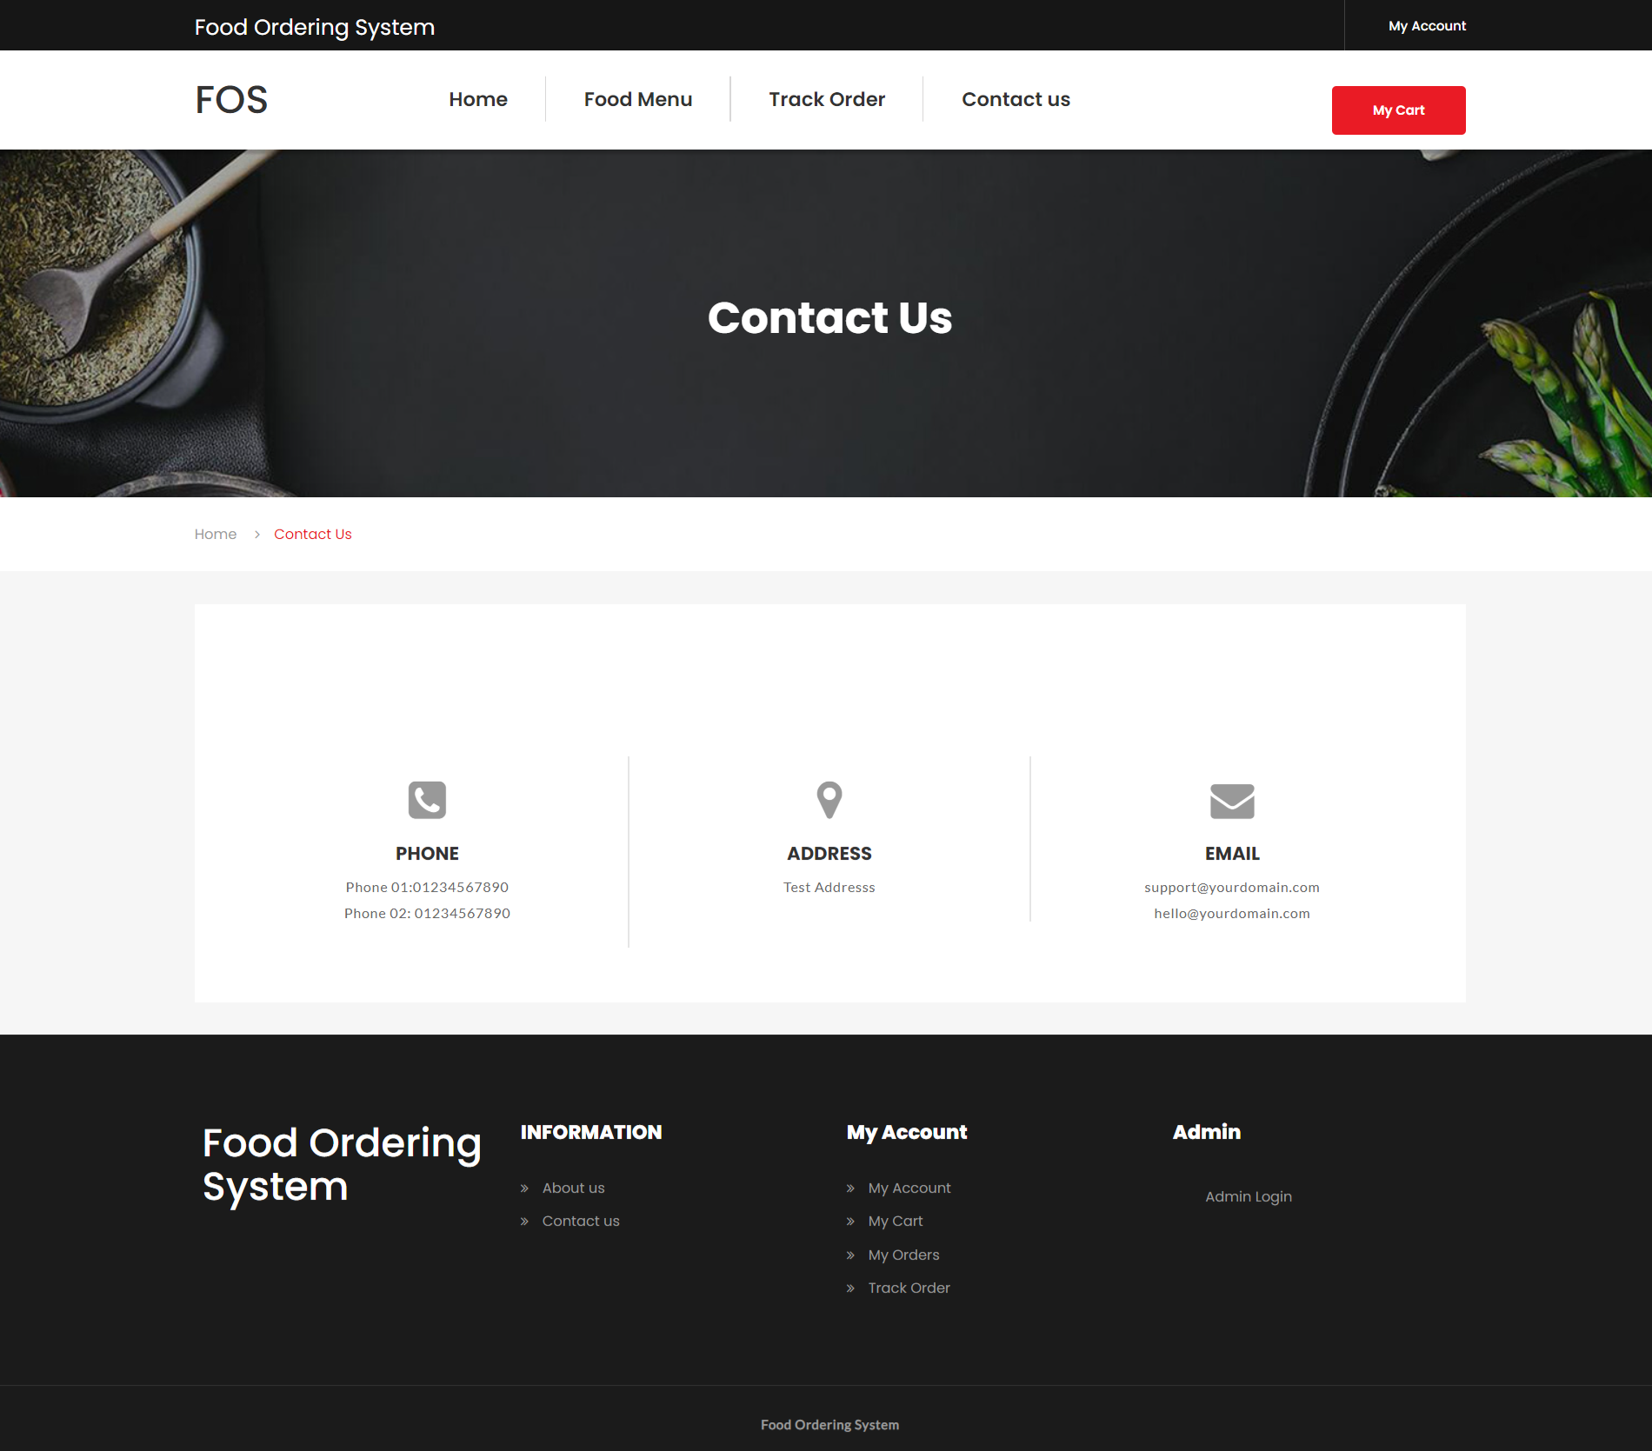

**Order Tracking Page**

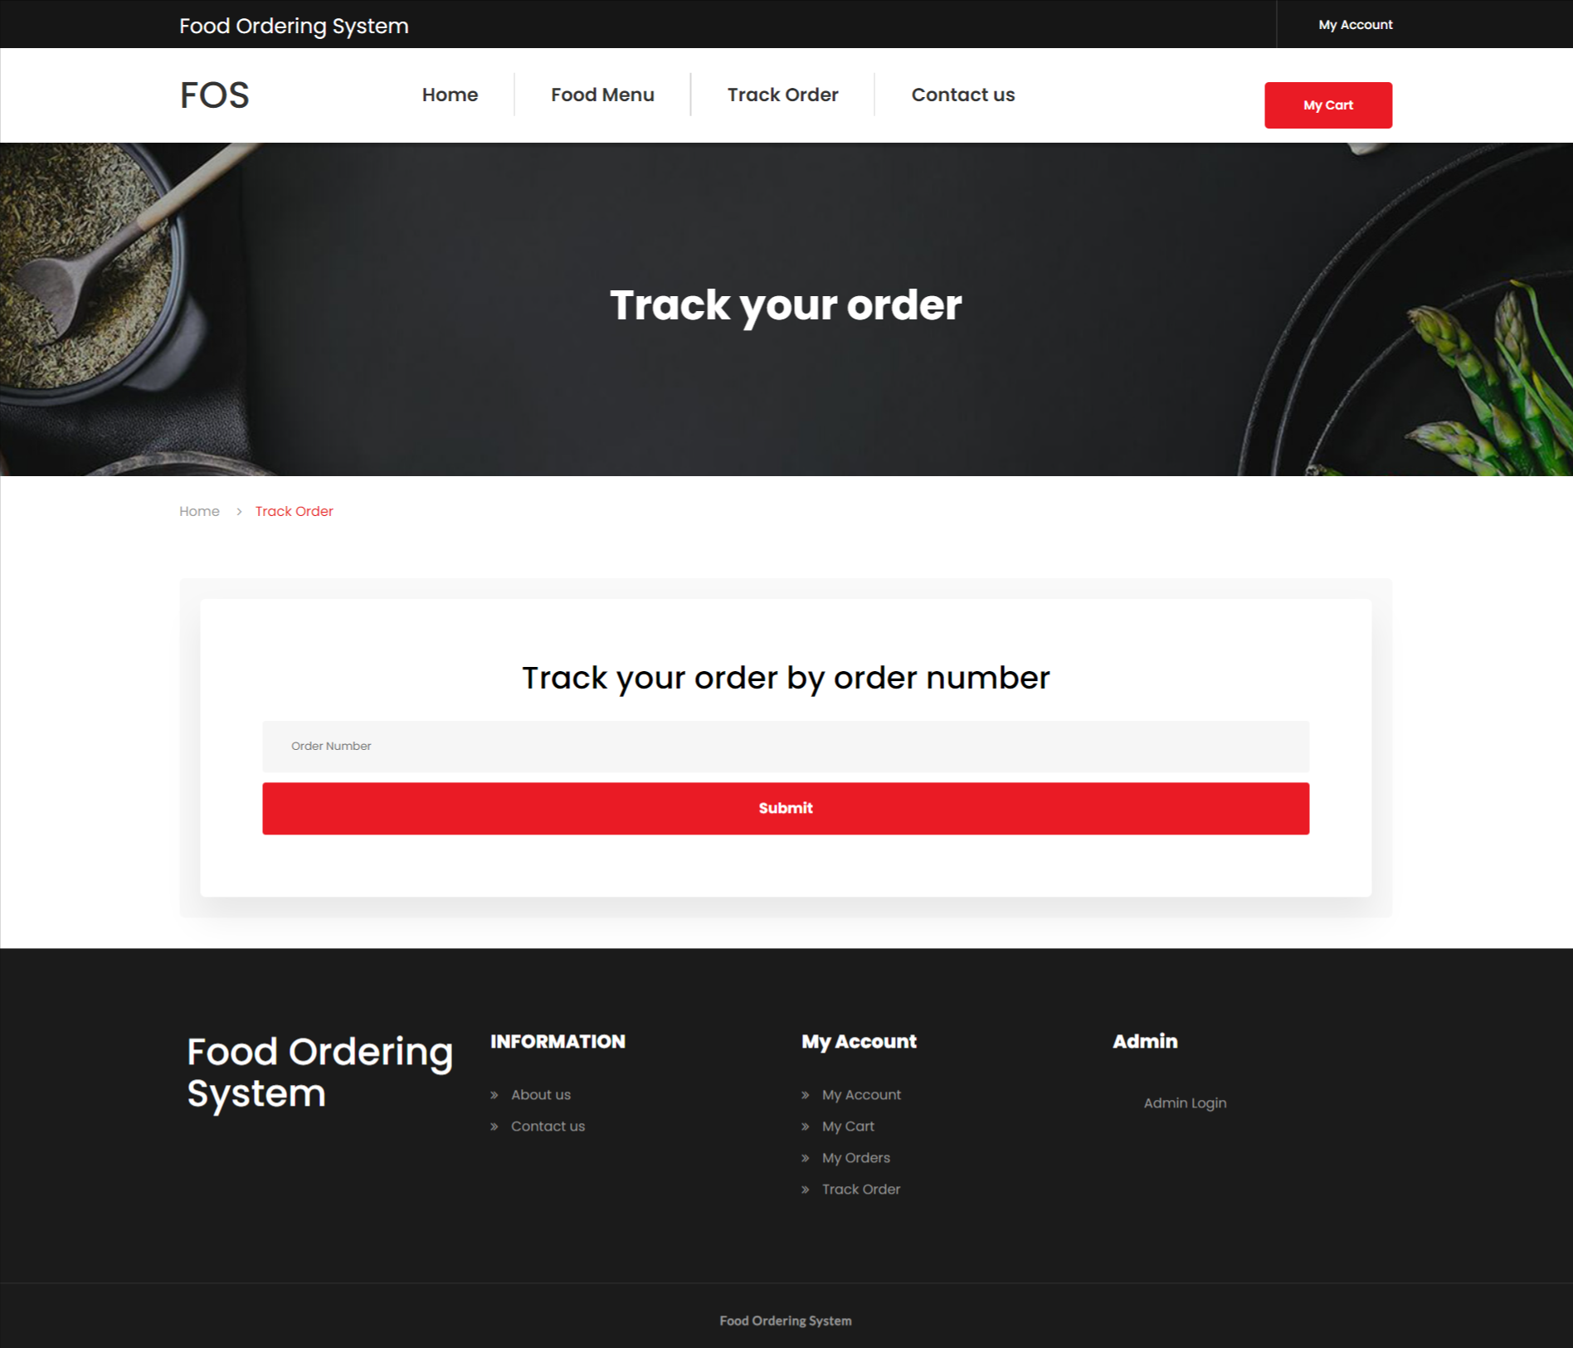

**User Panel**

**Signup Page**

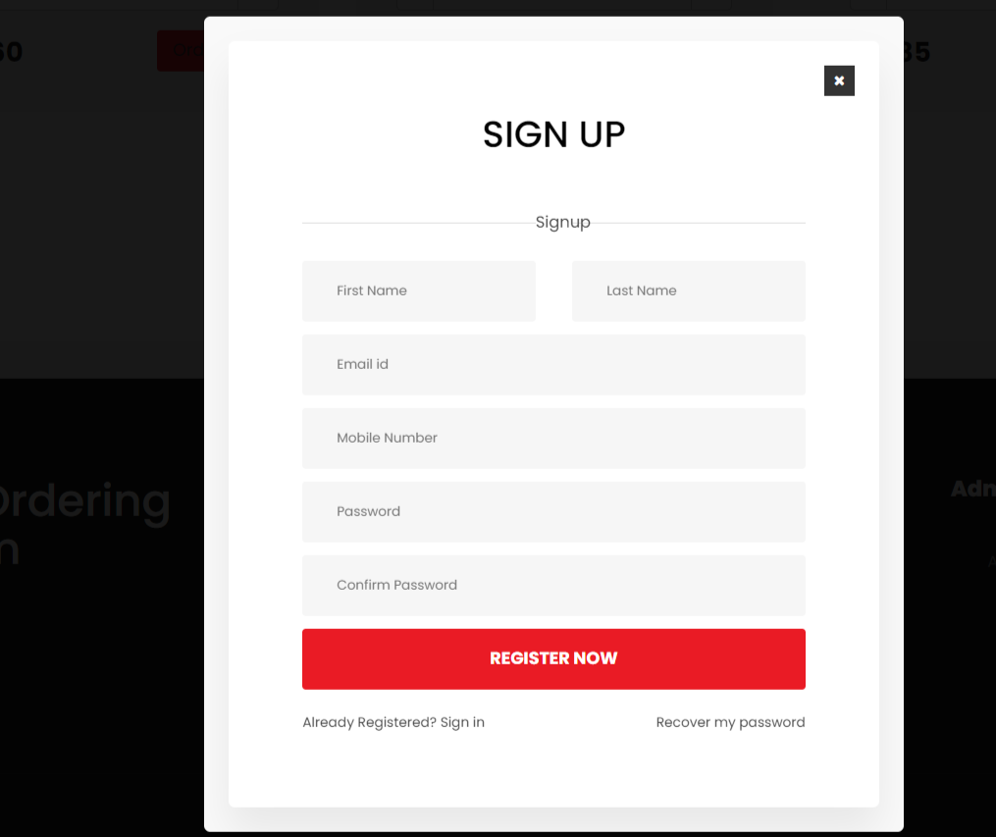

**Login Page**

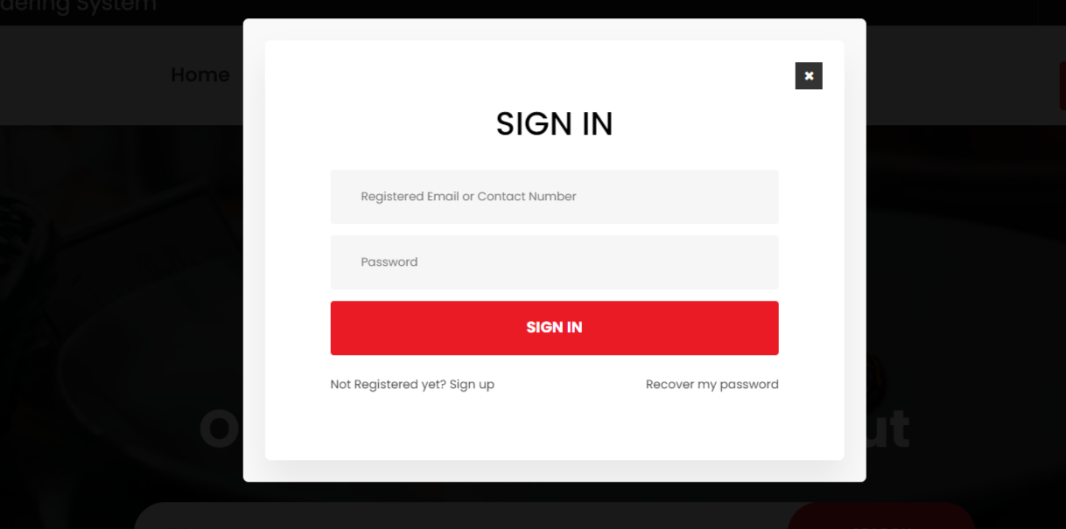

**Forgot Password**

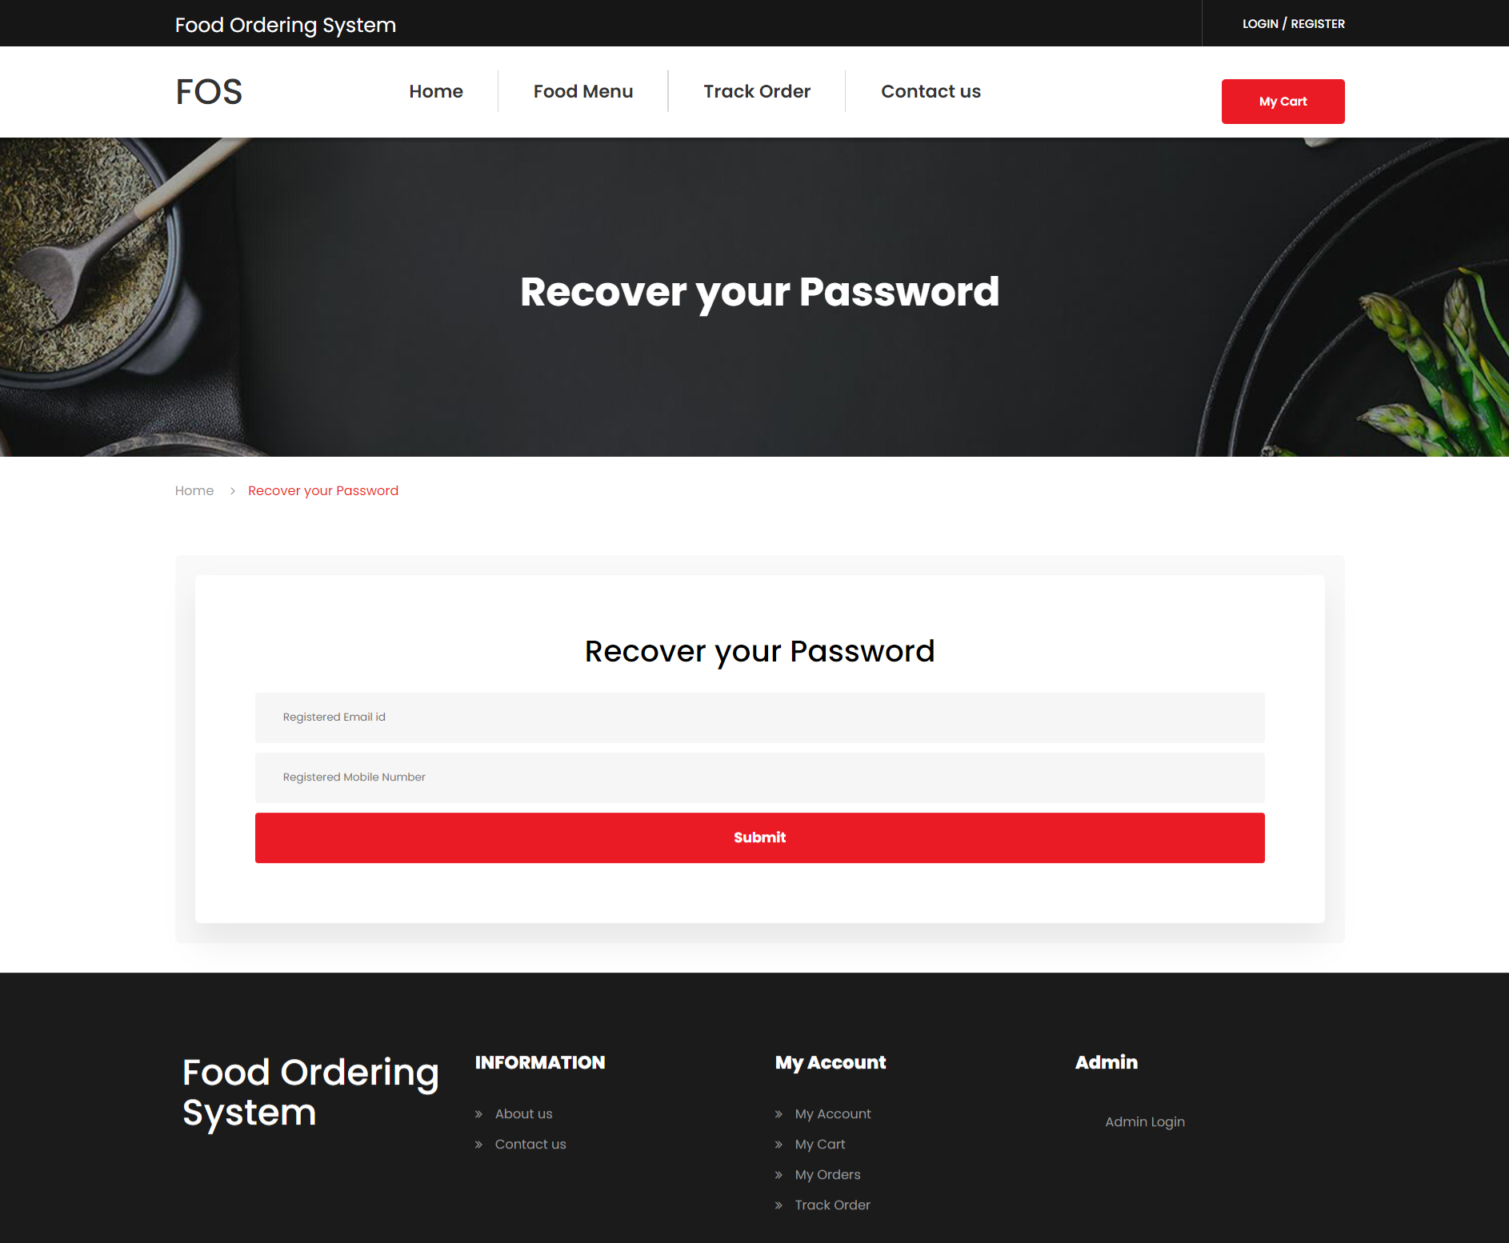

**Reset Password**

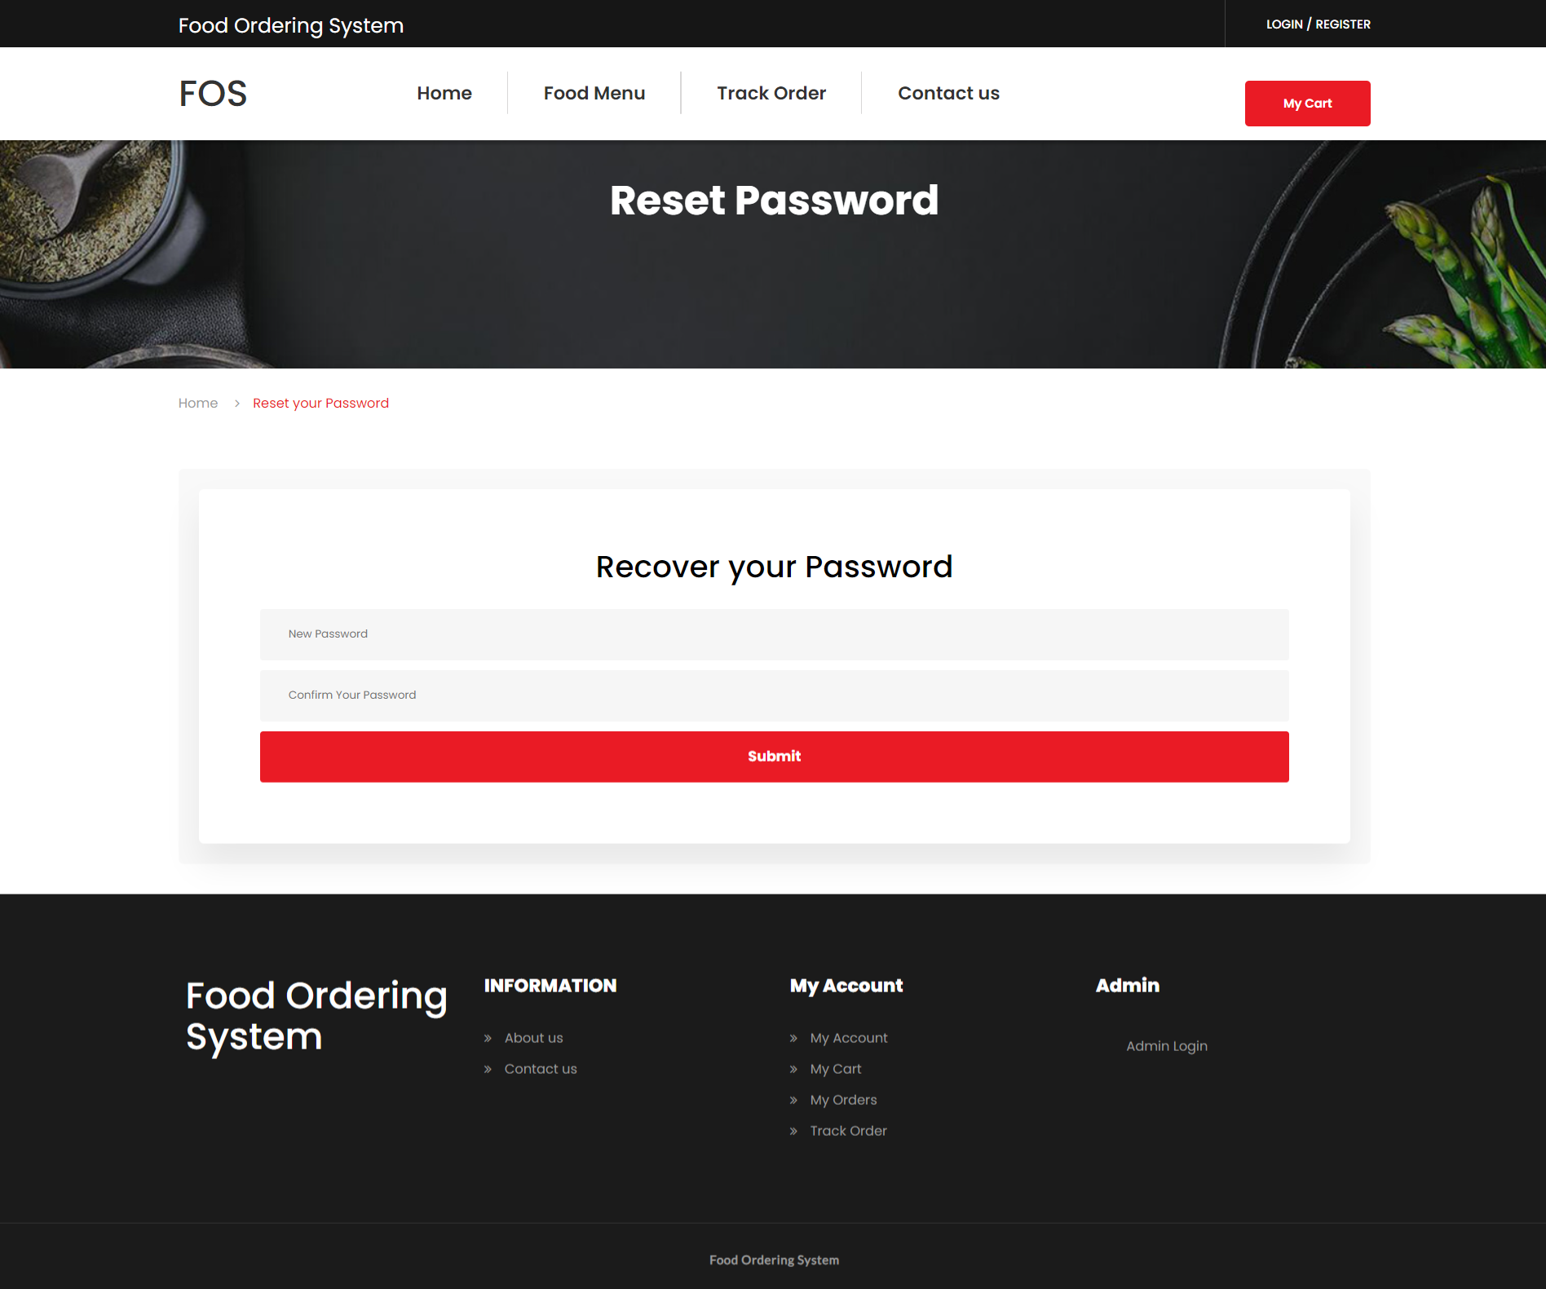

**My Account Page**

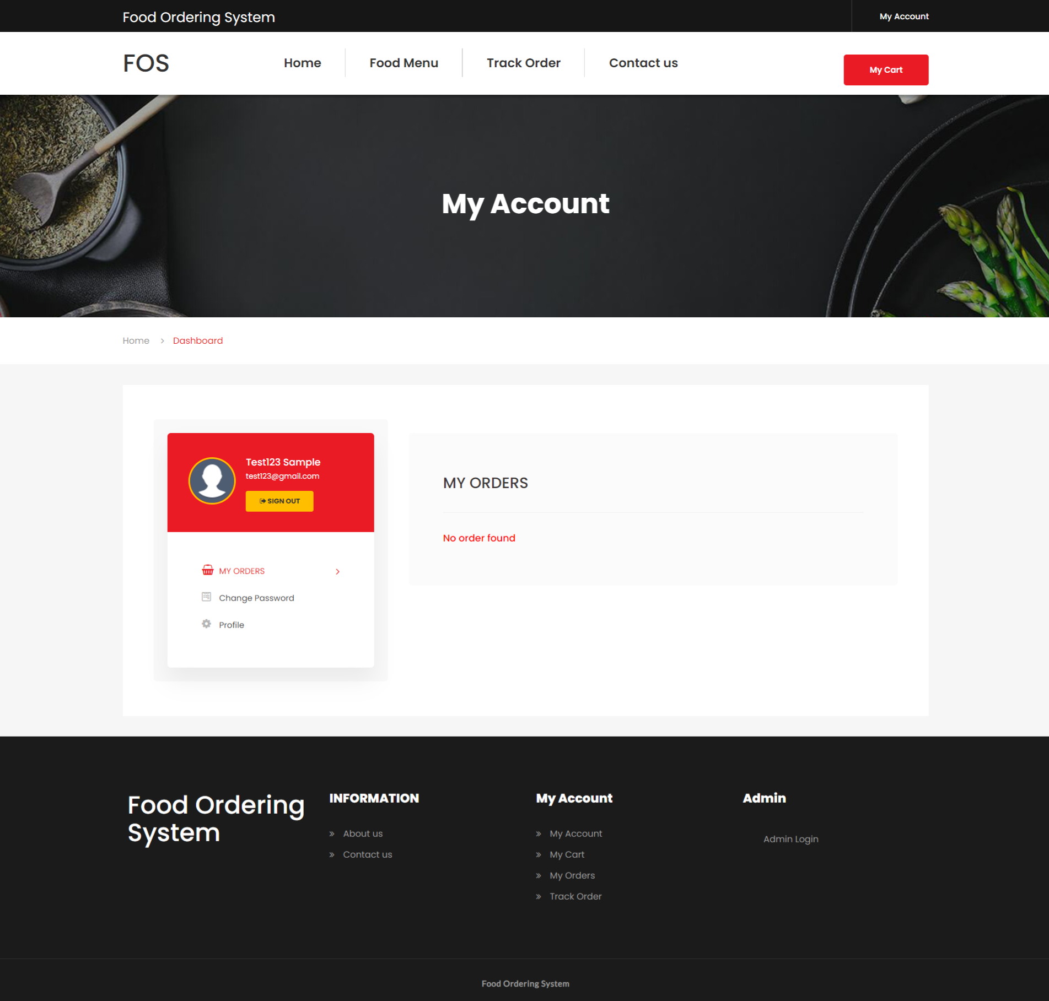

**Profile**

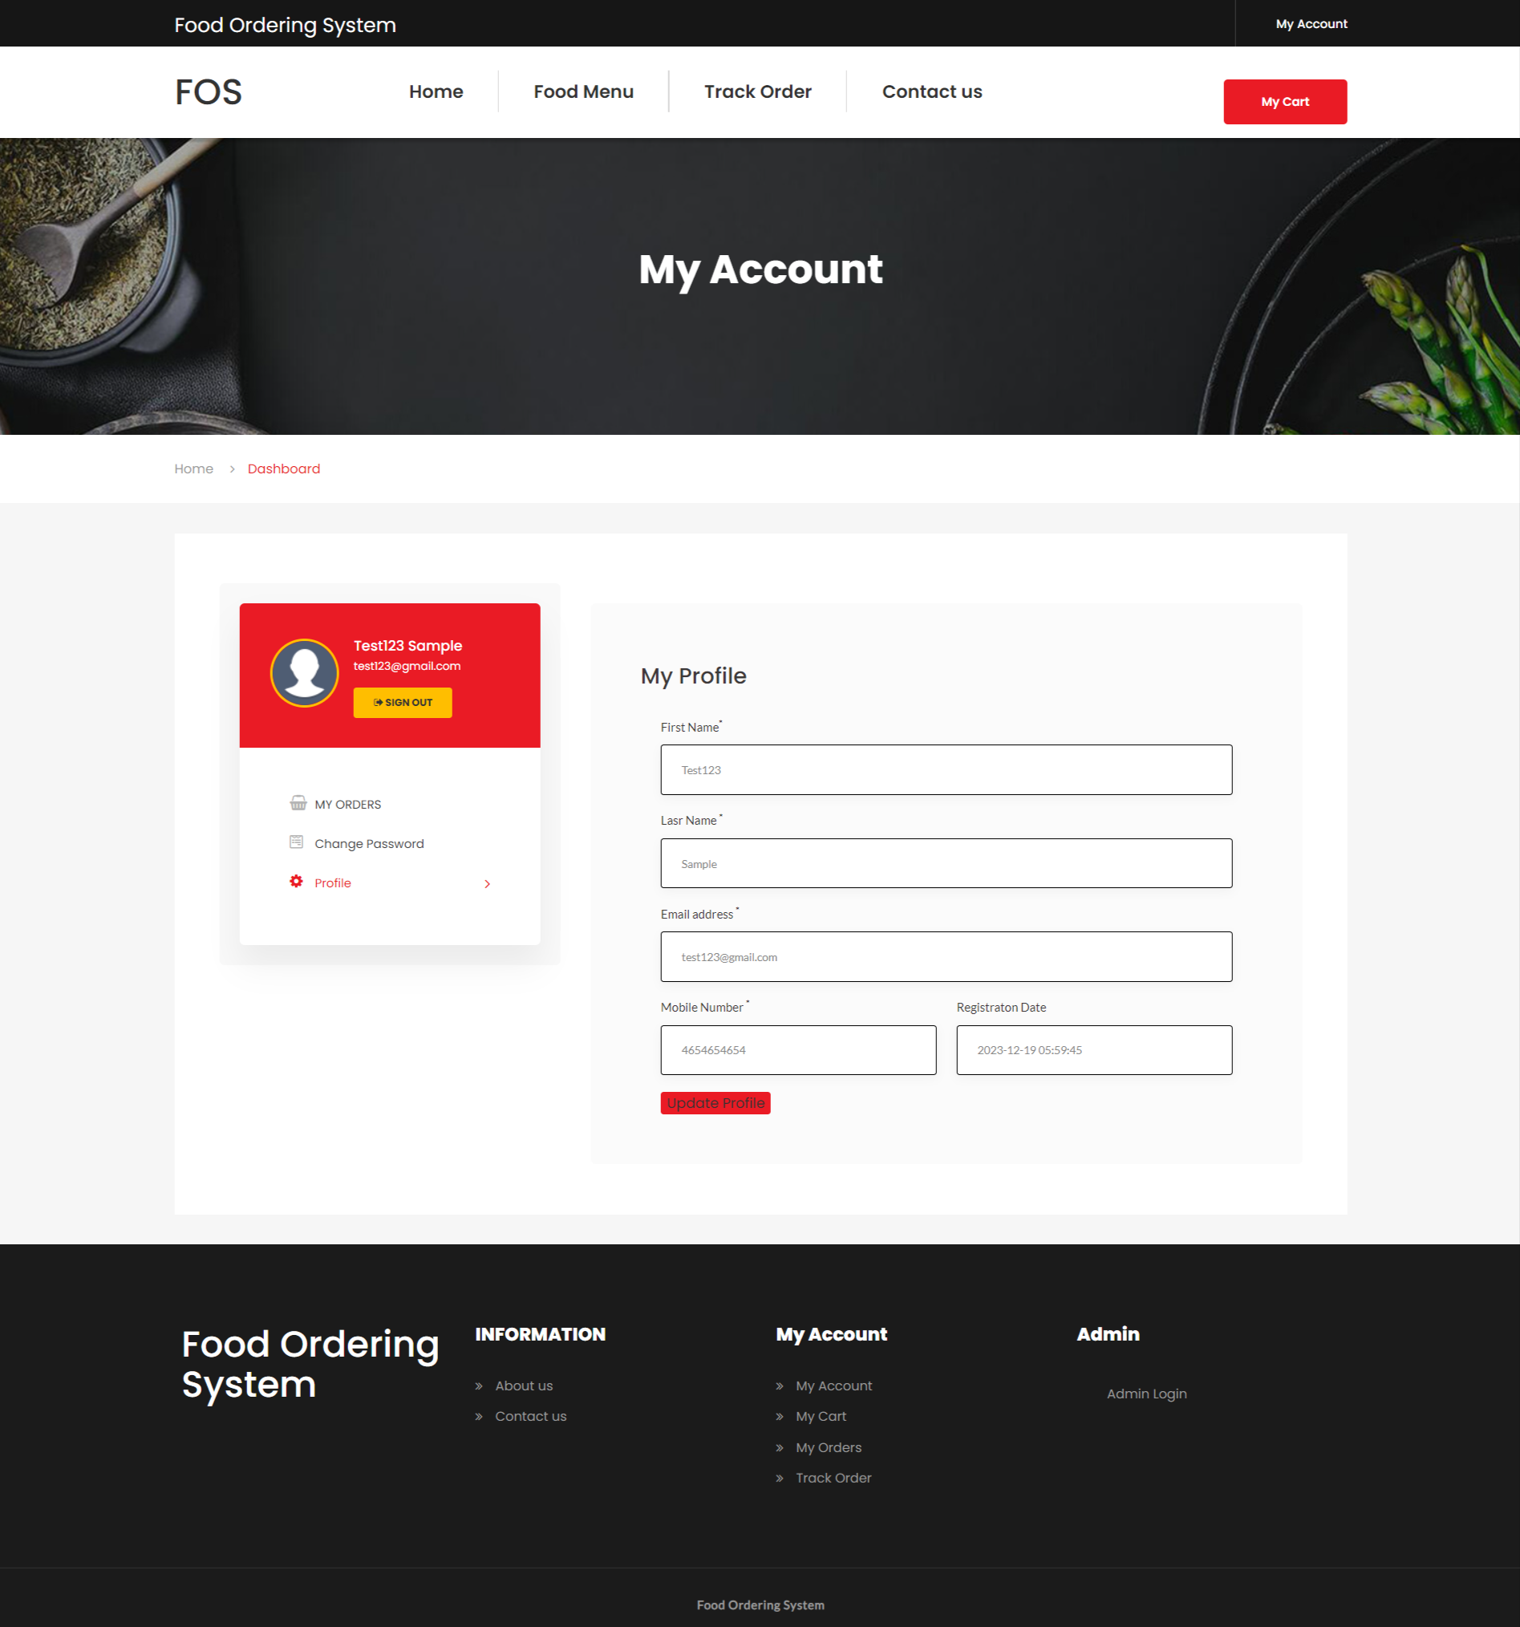

**Change Password**

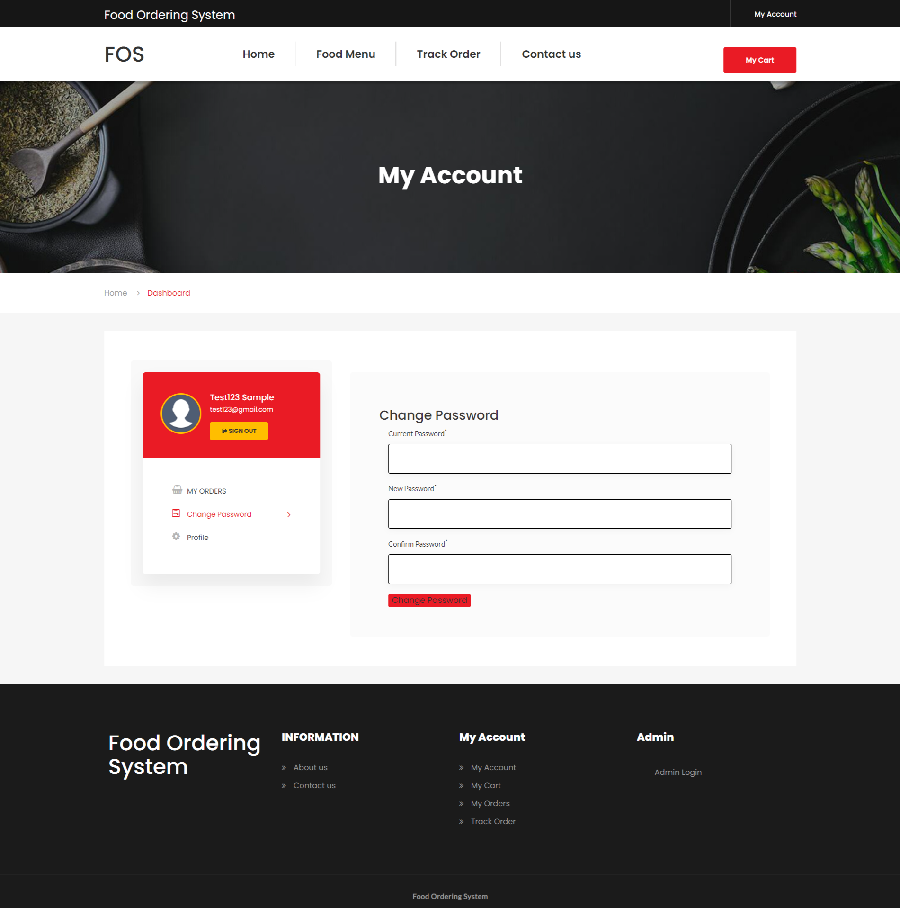

**Cart Page**

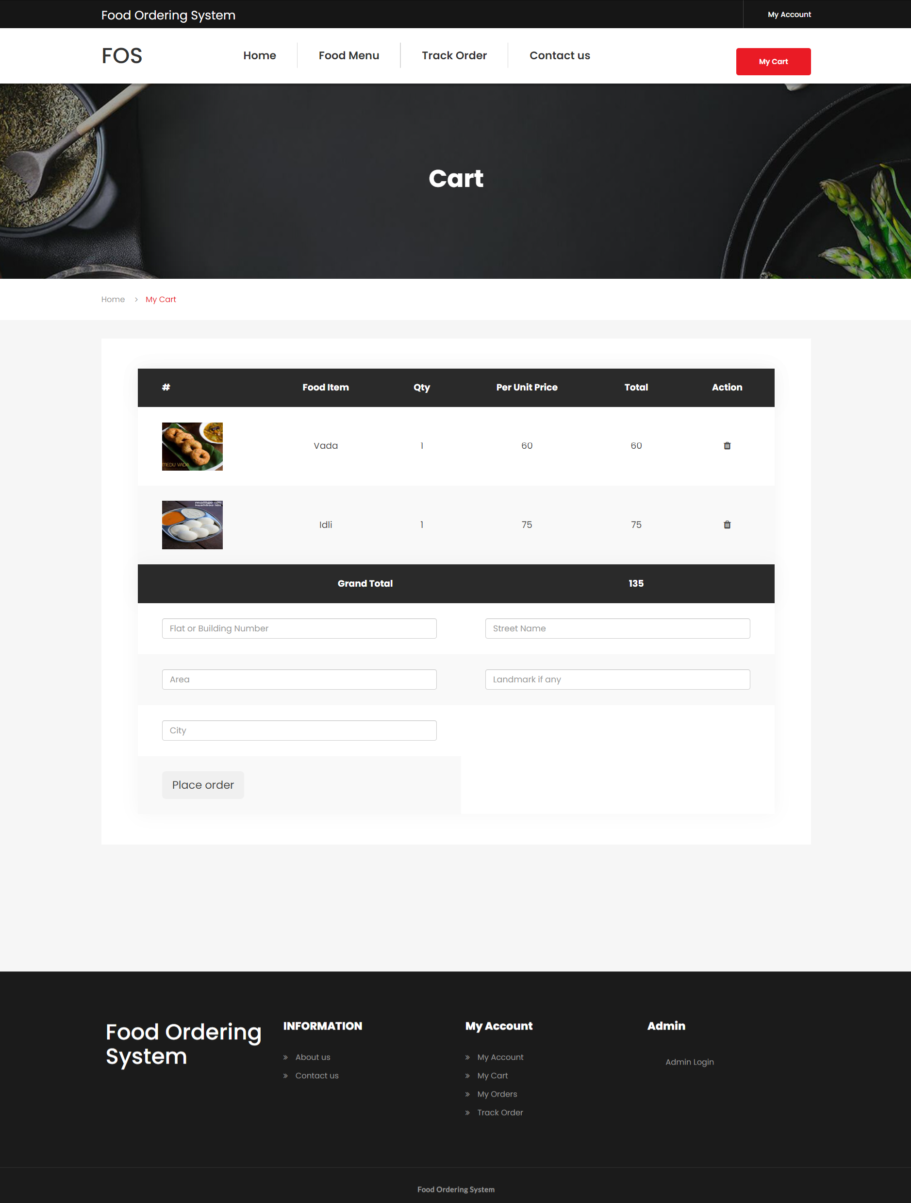

**Order Page**

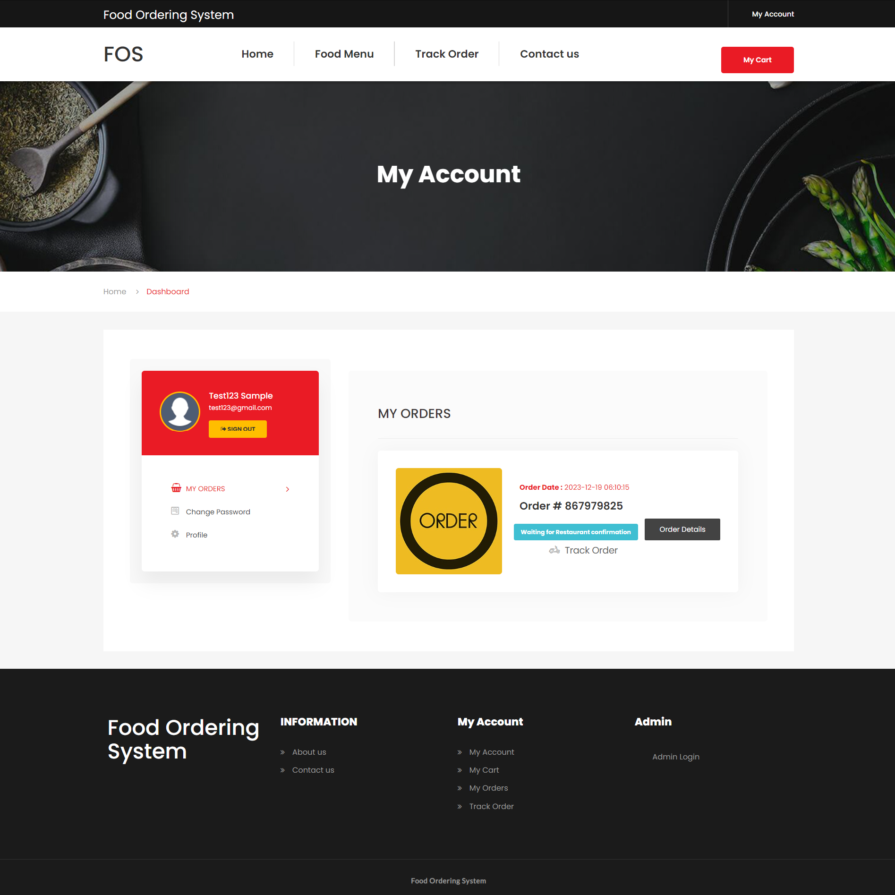

**View Order Details**

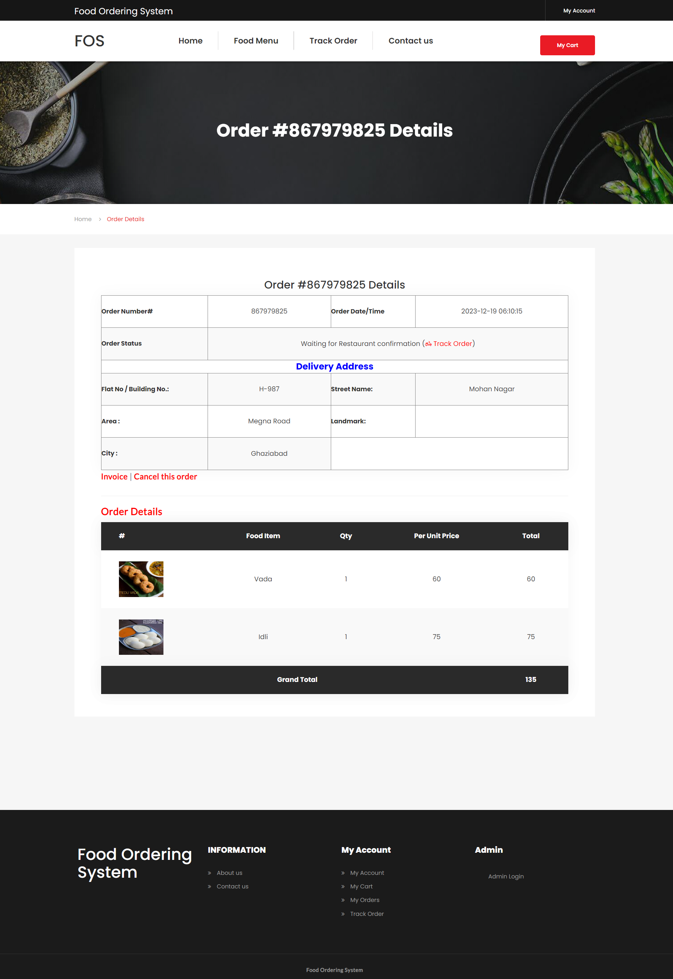

**Admin Panel**

**Login Page**

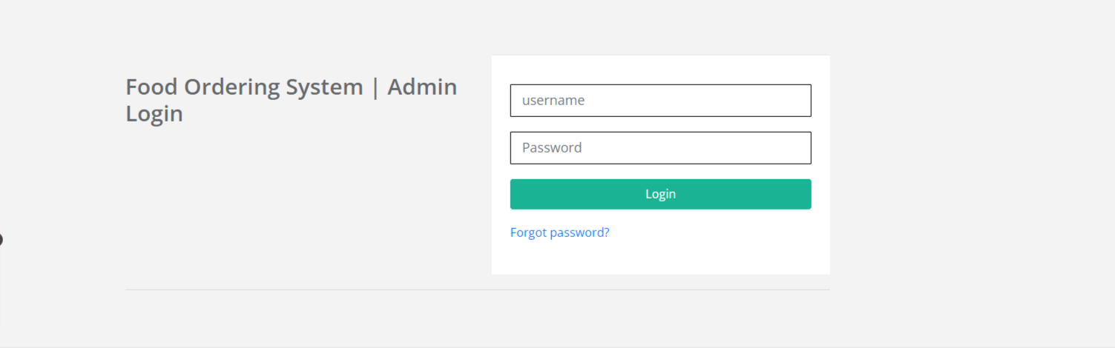

**Forgot Password**

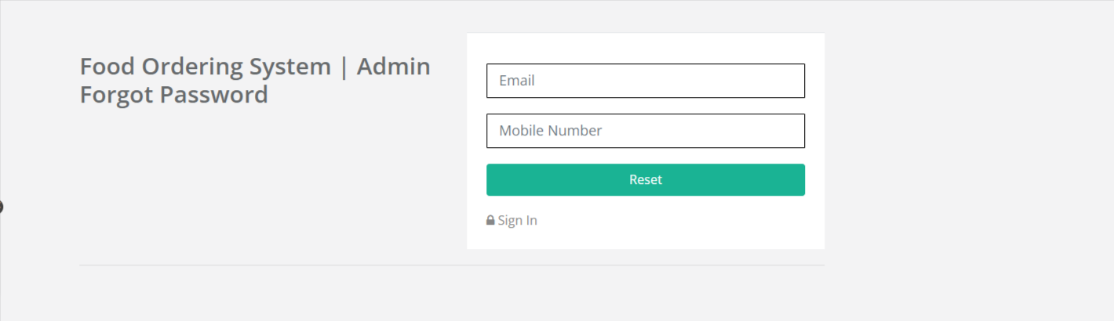

**Reset Password**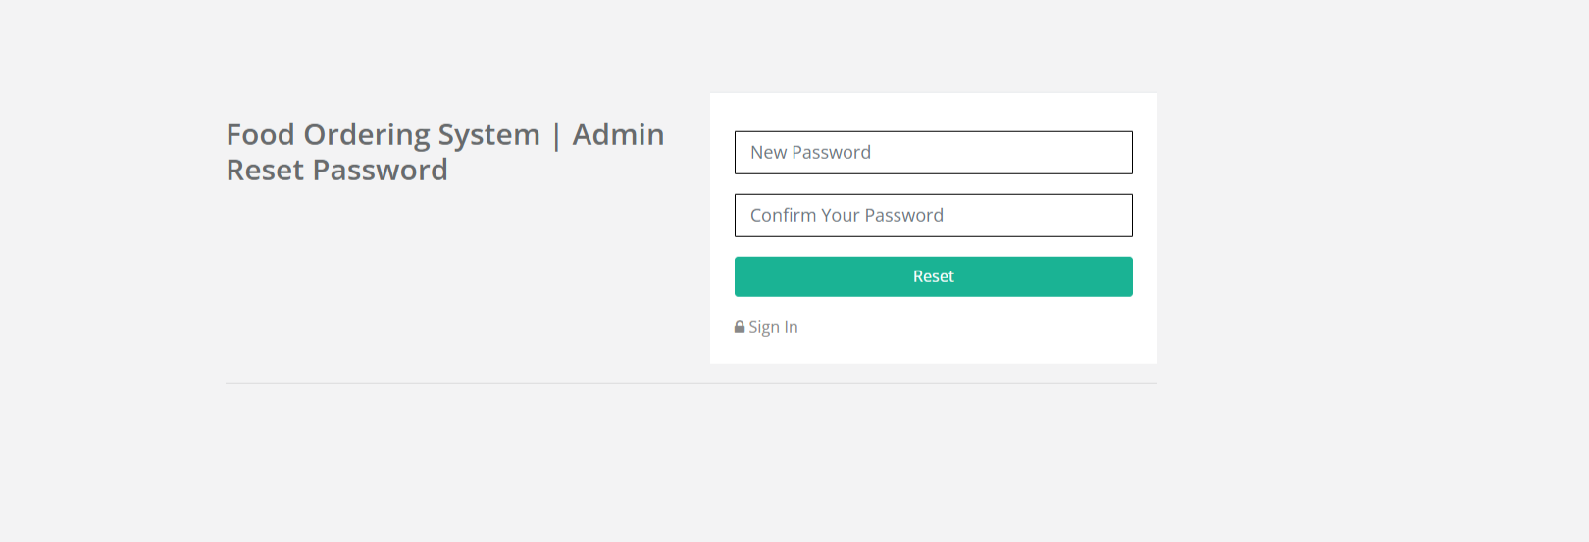

**Dashboard**

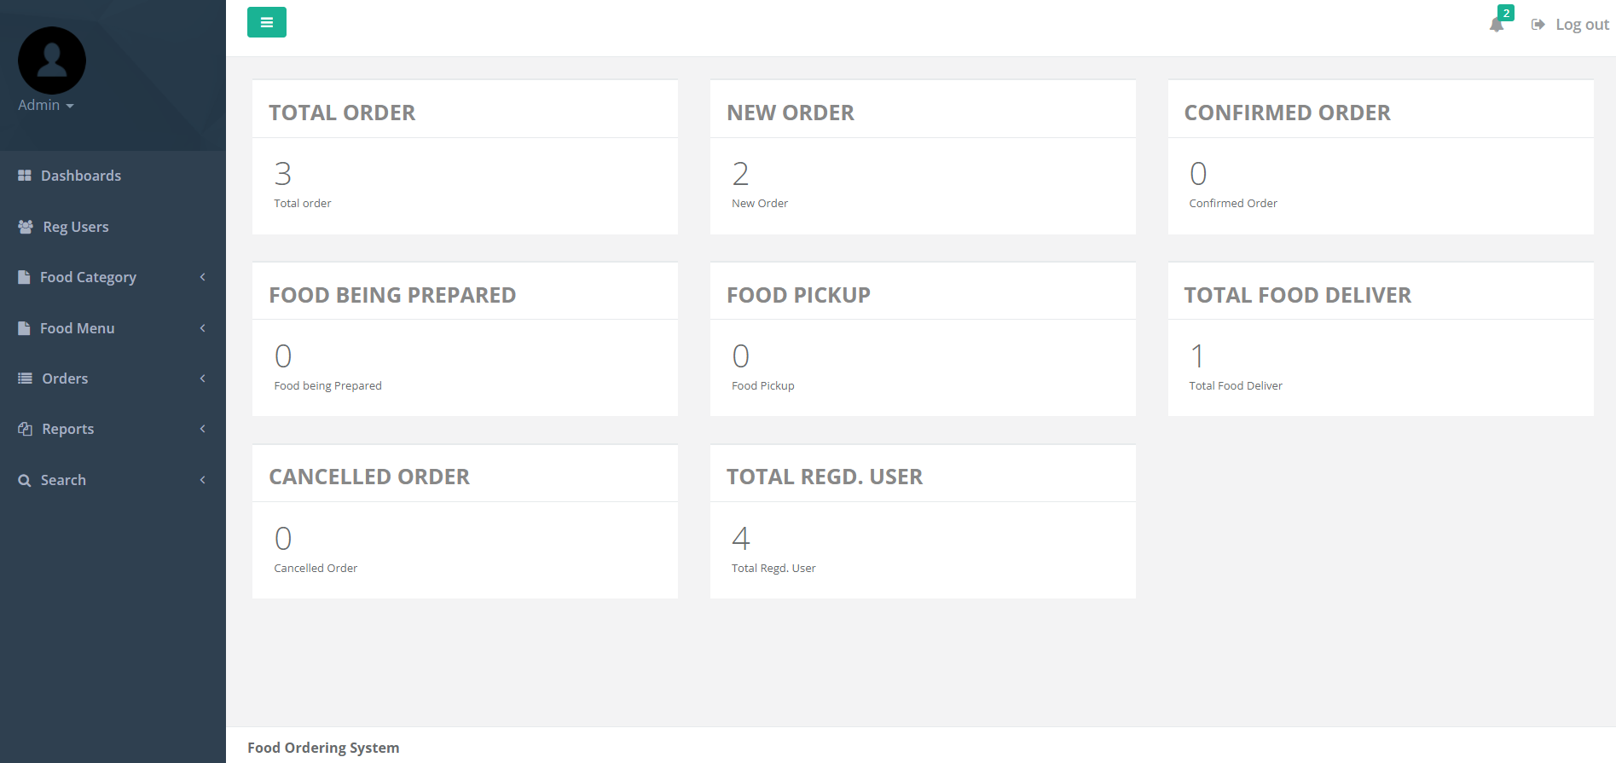

**Profile**

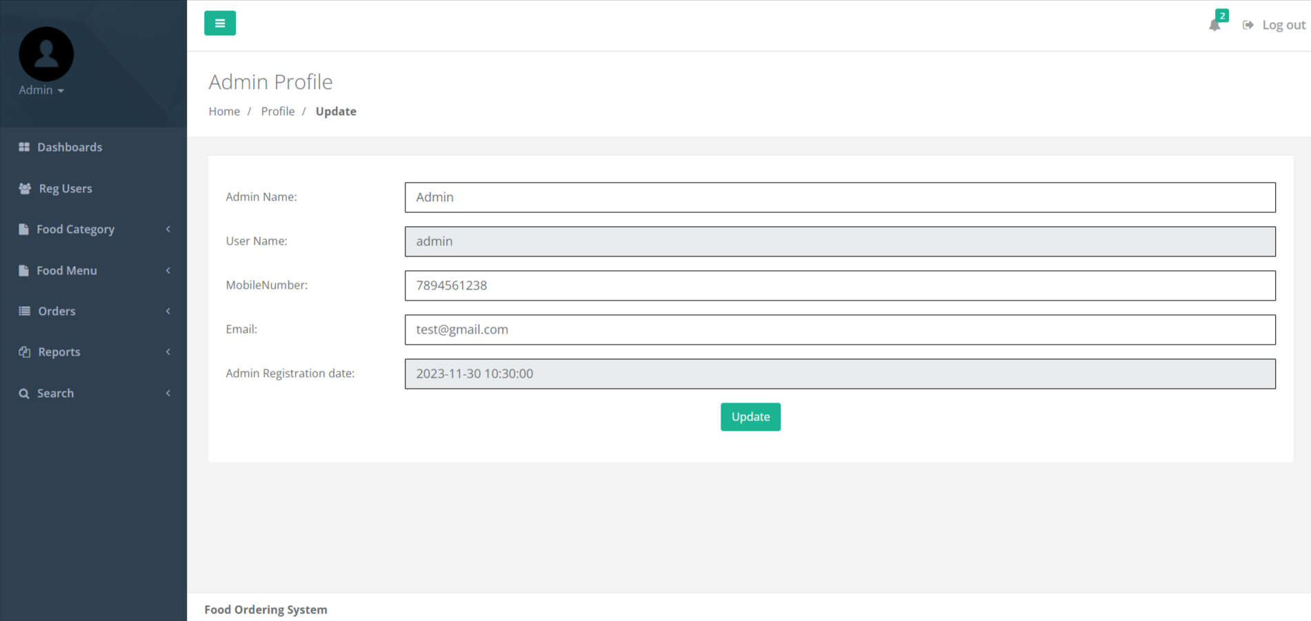

**Change Password**

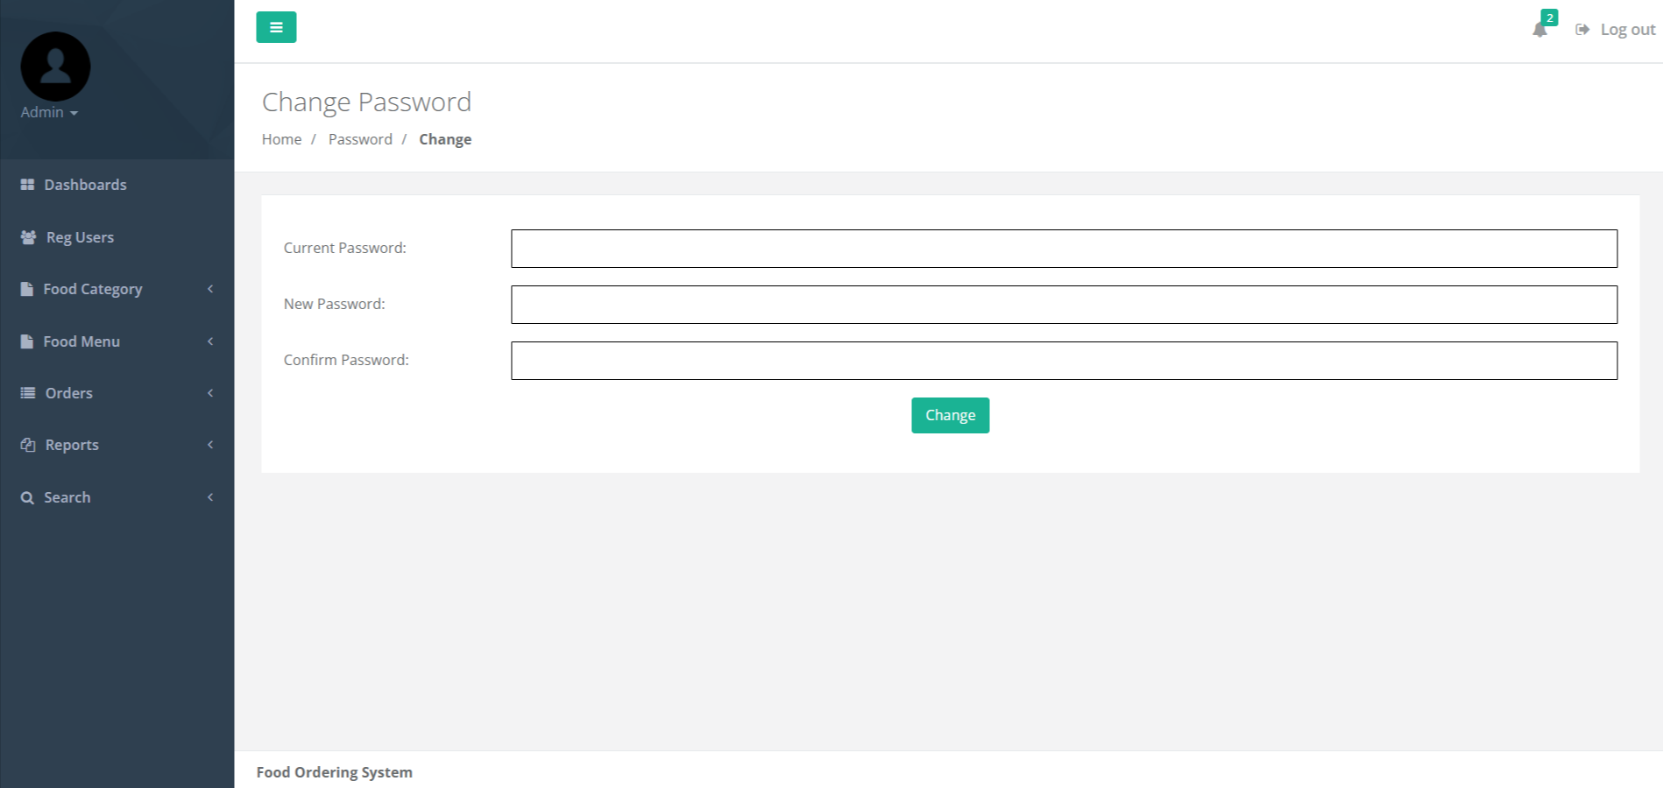

**Add Food Category**

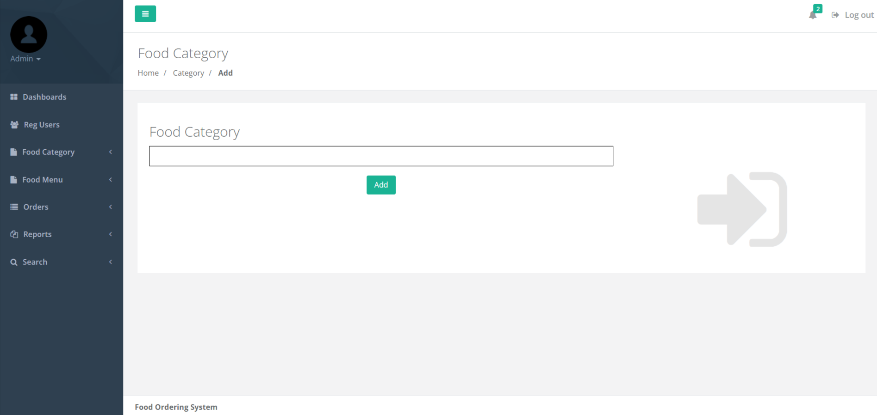

**Manage Food Category**

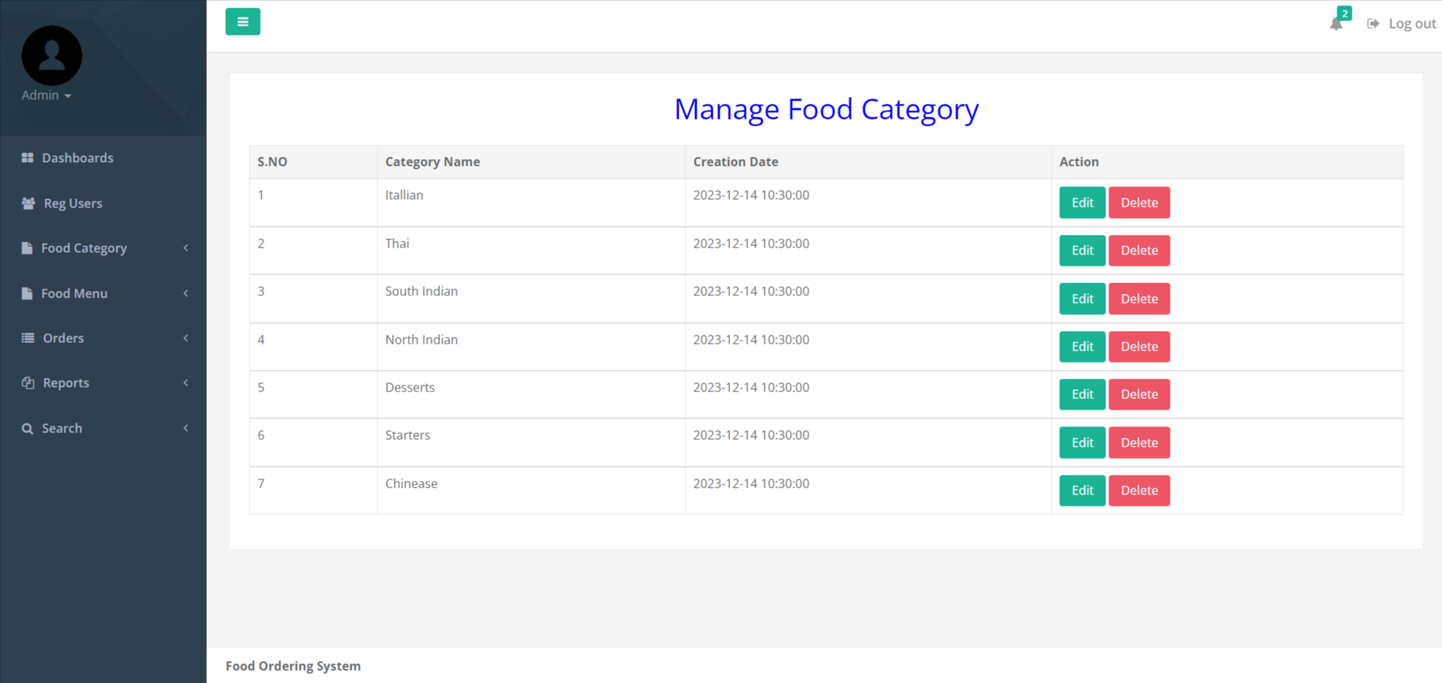

**Update Food Category**

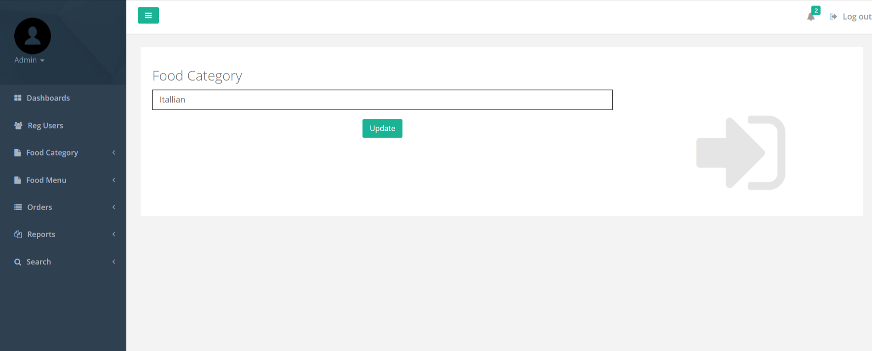

**Add Food Menu**

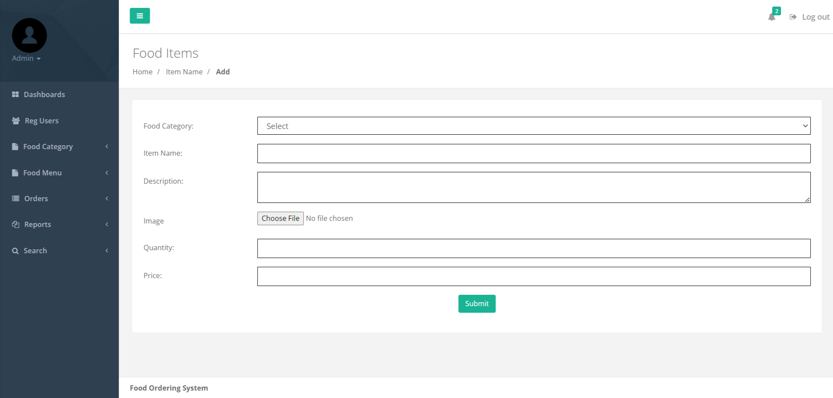

**Manage Food Menu**

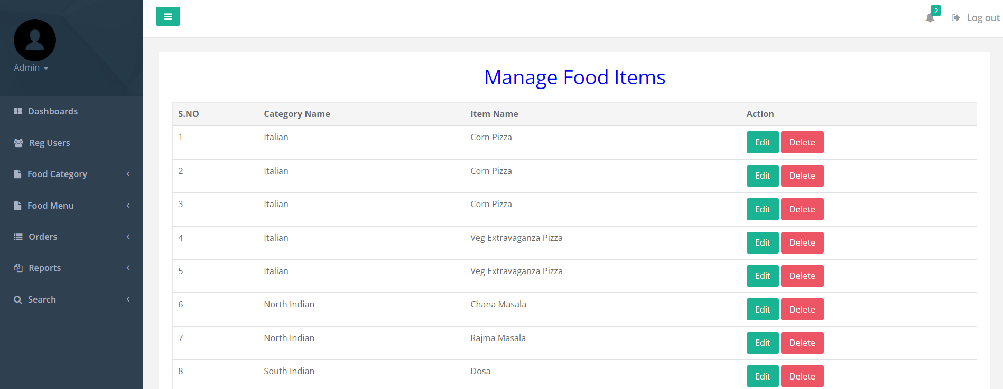

**Update Food Menu**

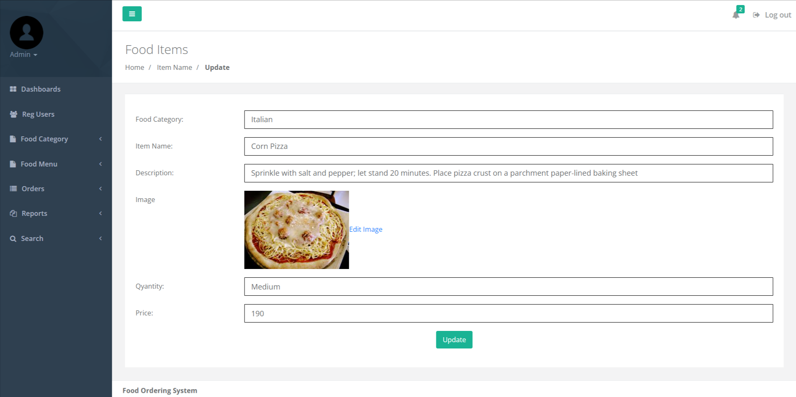

**Update Food Image**

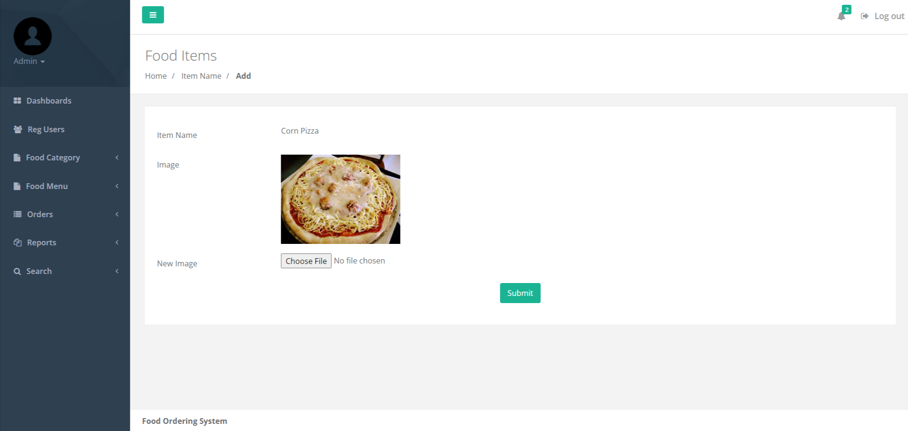

**New Order (Order not Confirmed yet)**

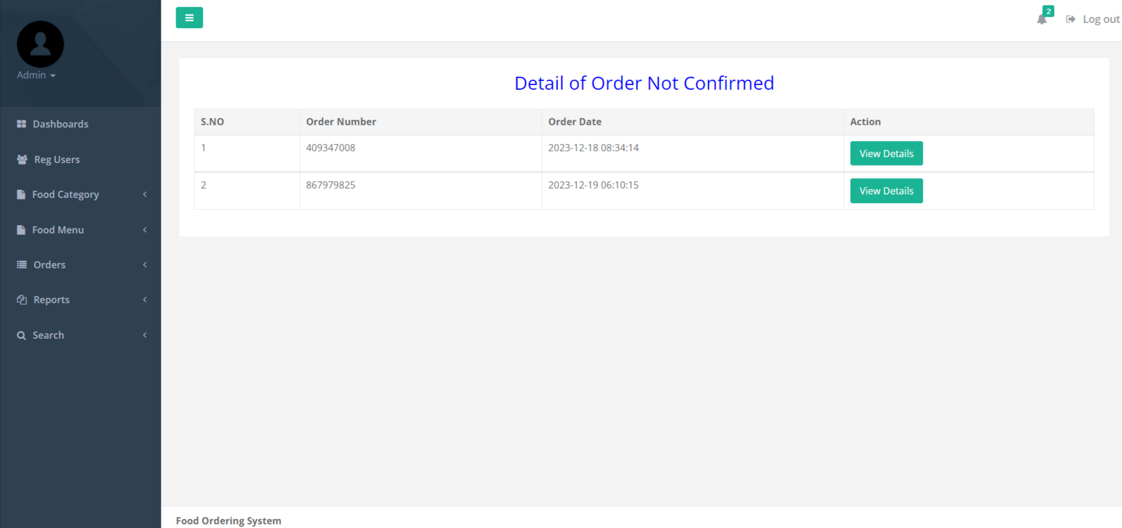

**View New Order Details**

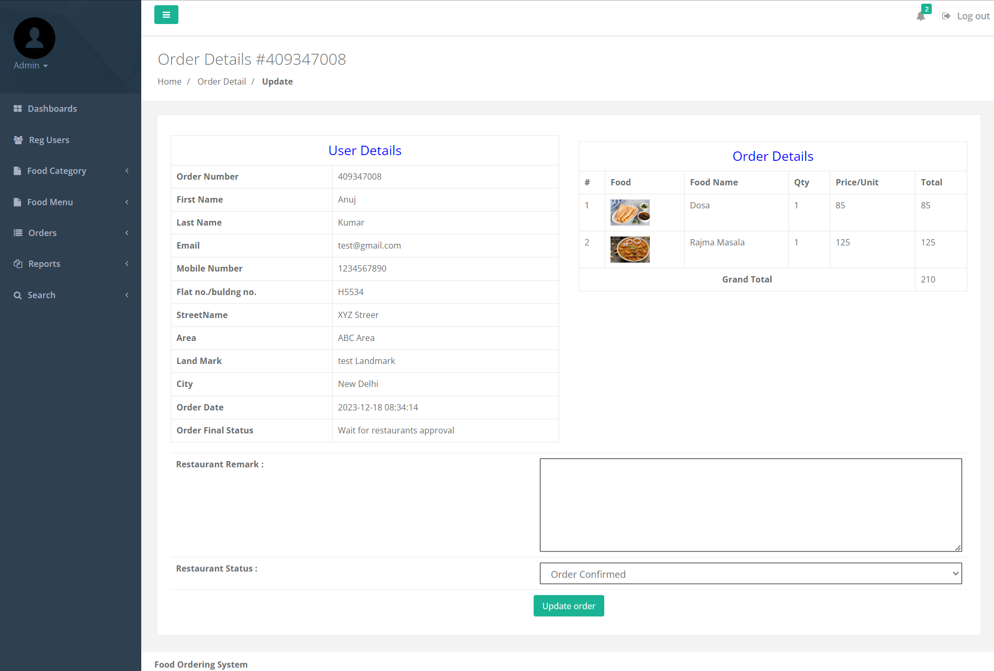

**Confirmed Orders**

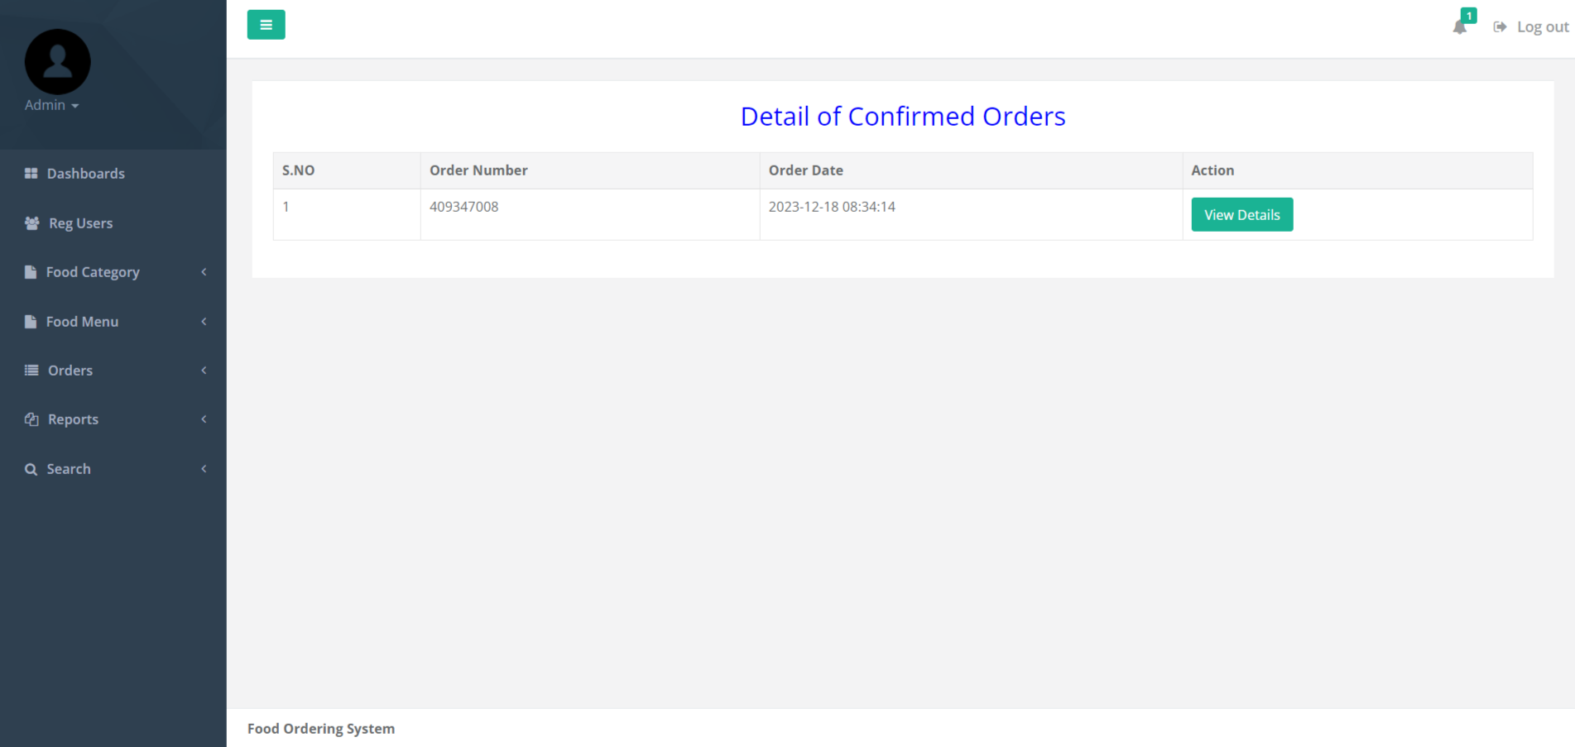

**View Confirmed Orders**

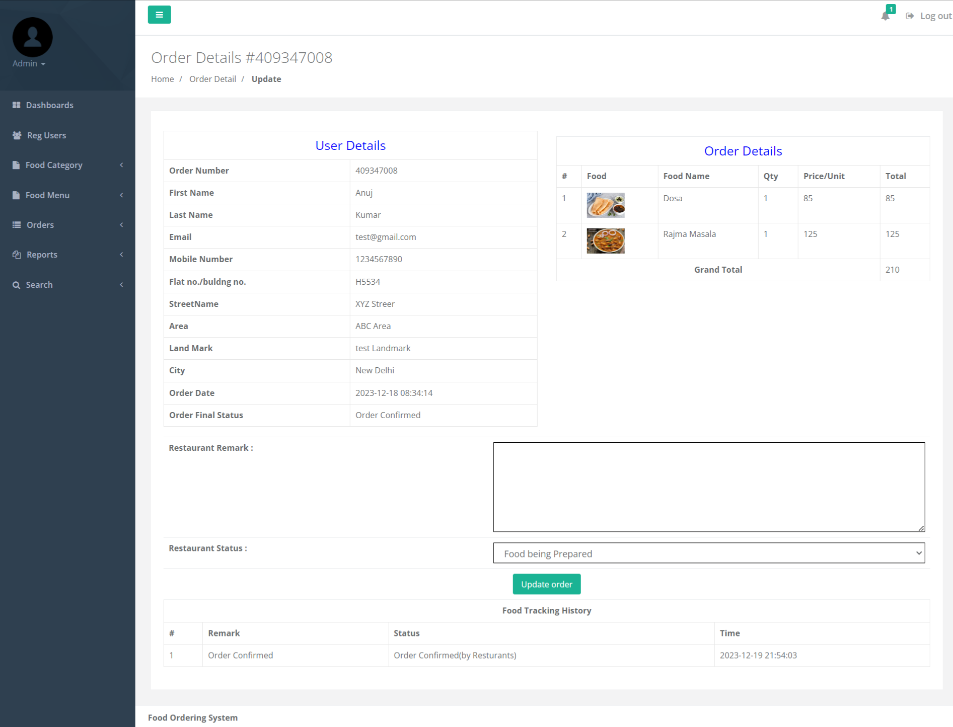

**Delivered Order**

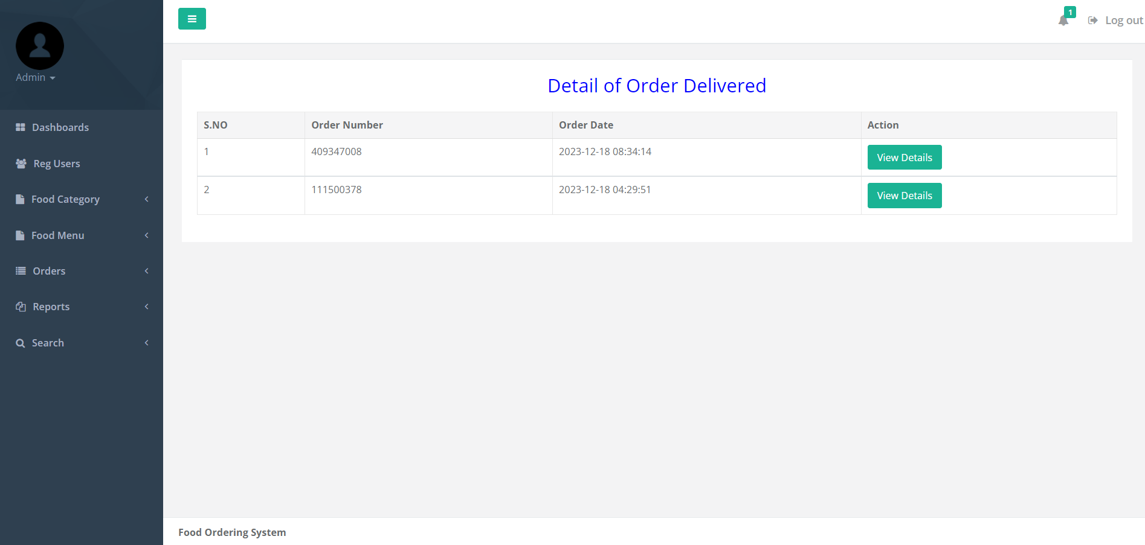

**View Delivered Order Details**

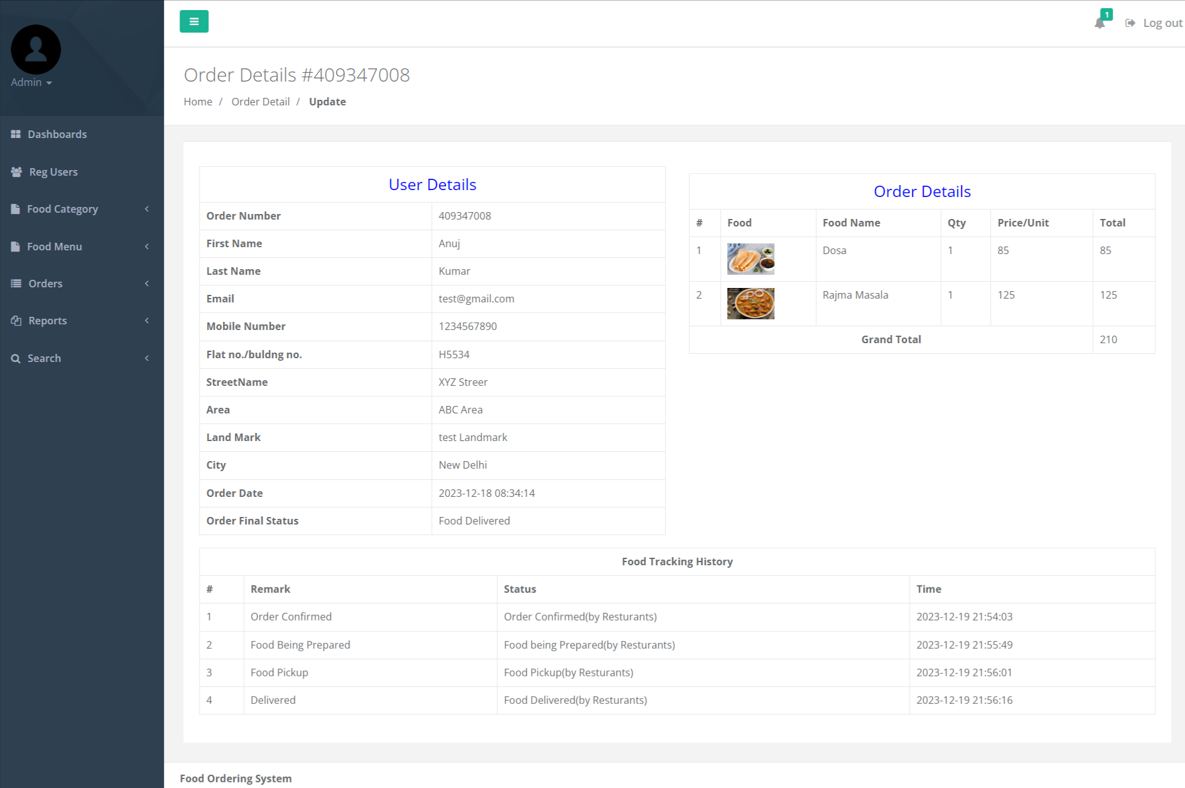

**Registered Users**

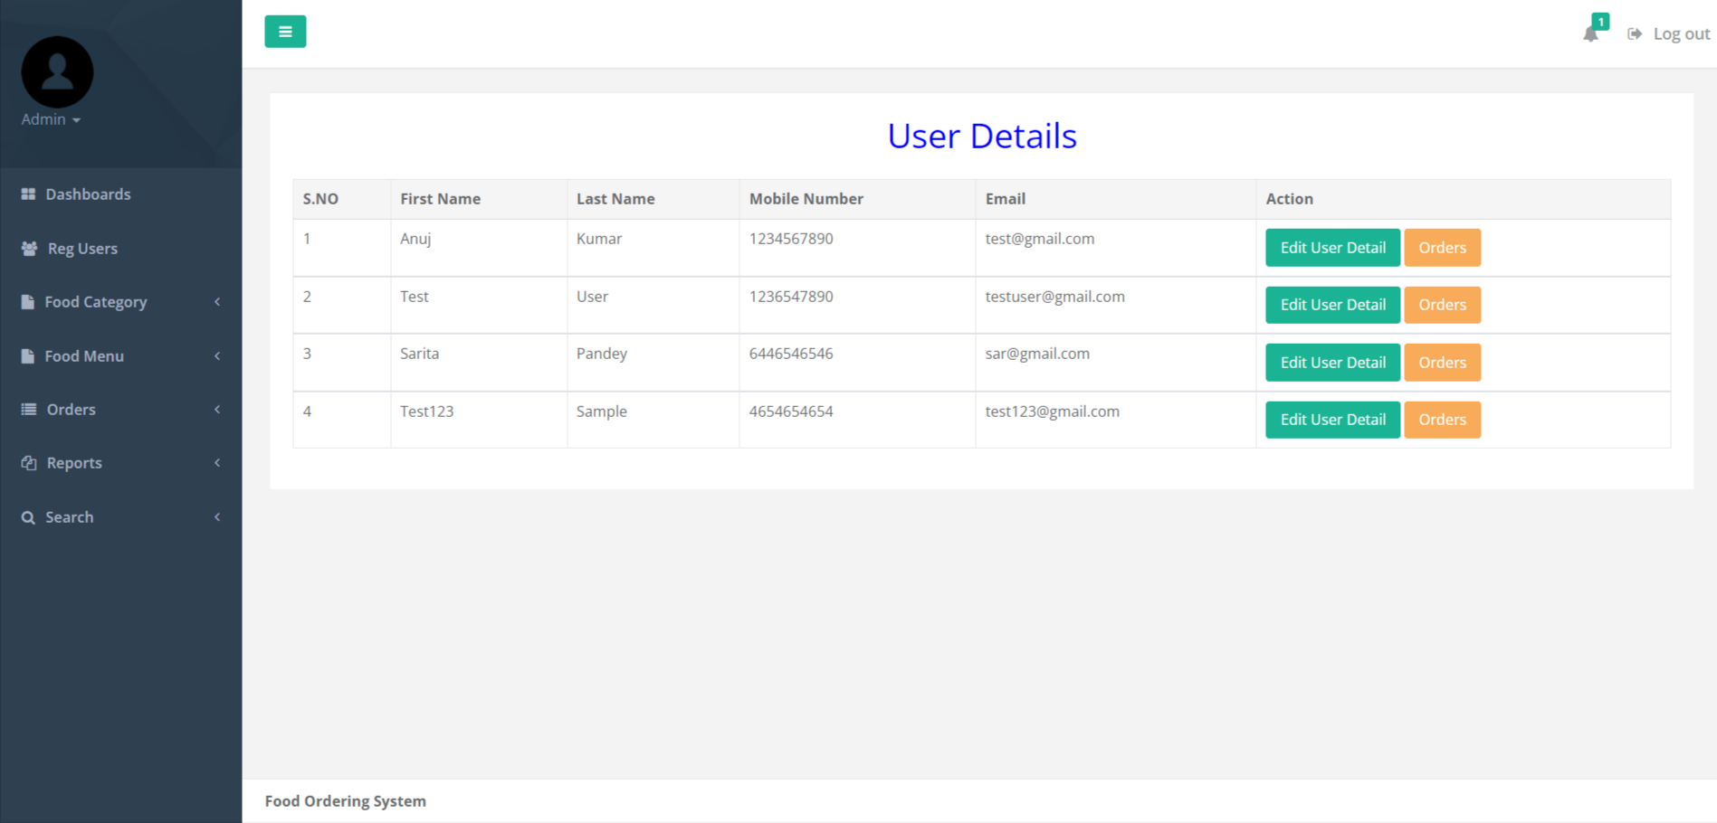

**View Registered User’s Orders Details**

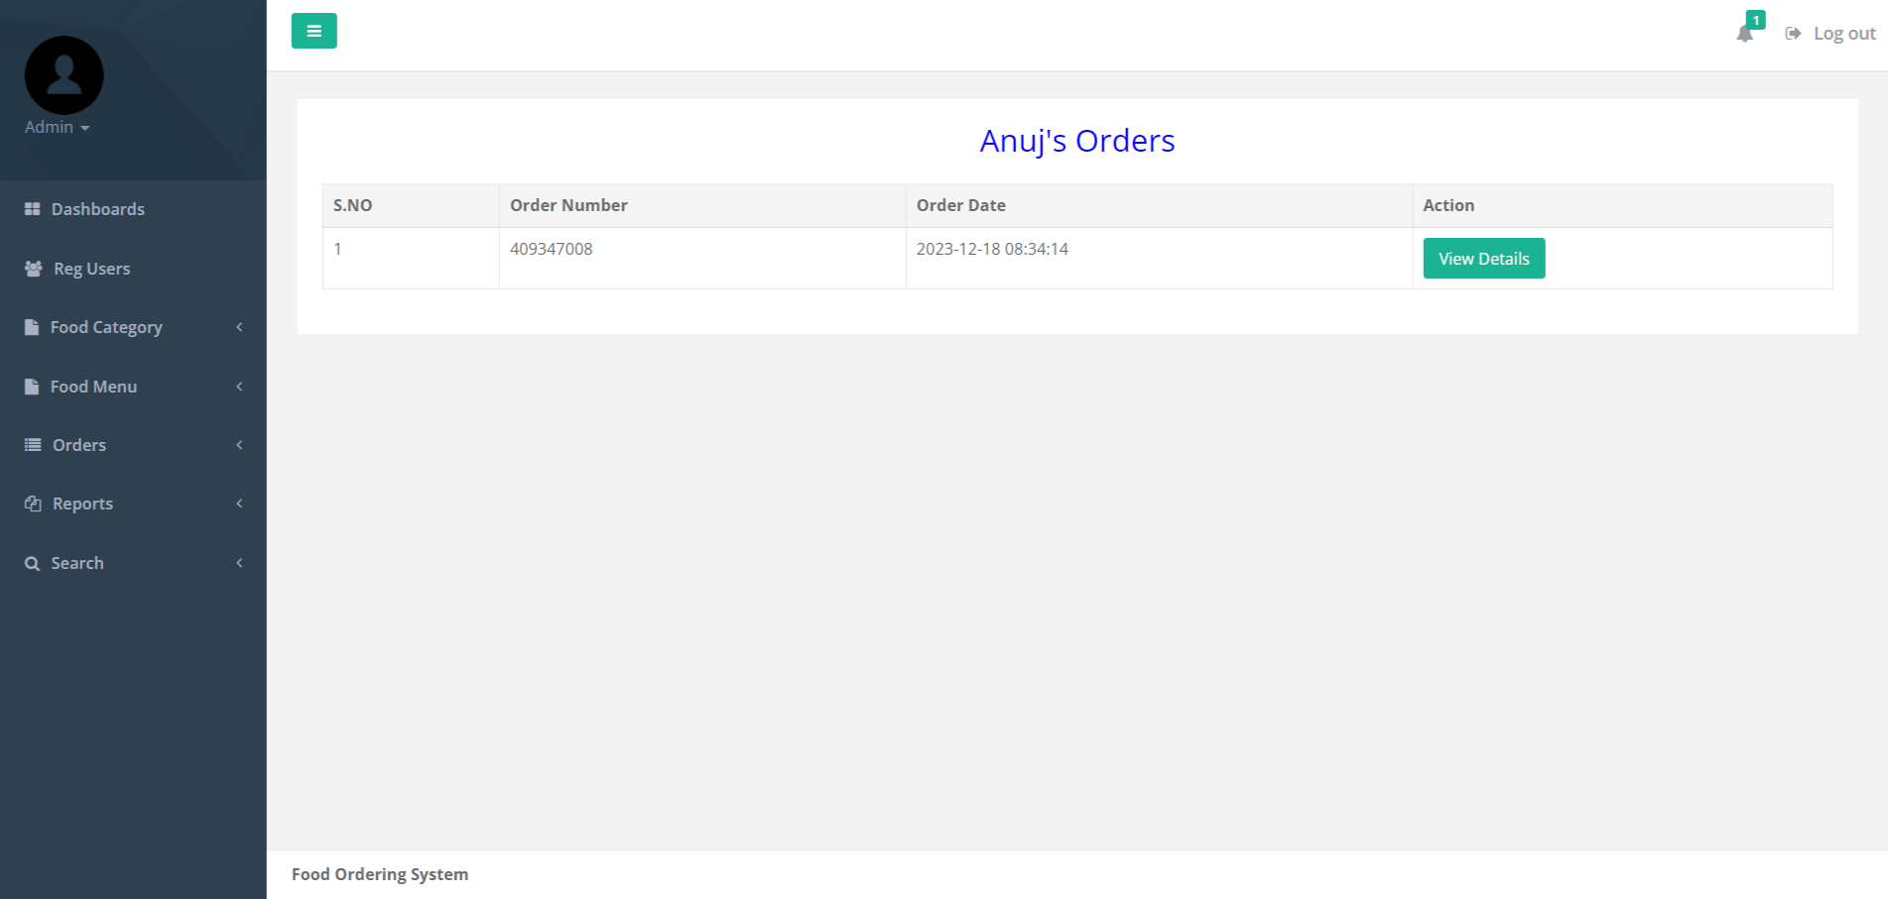

**Edit User Details**

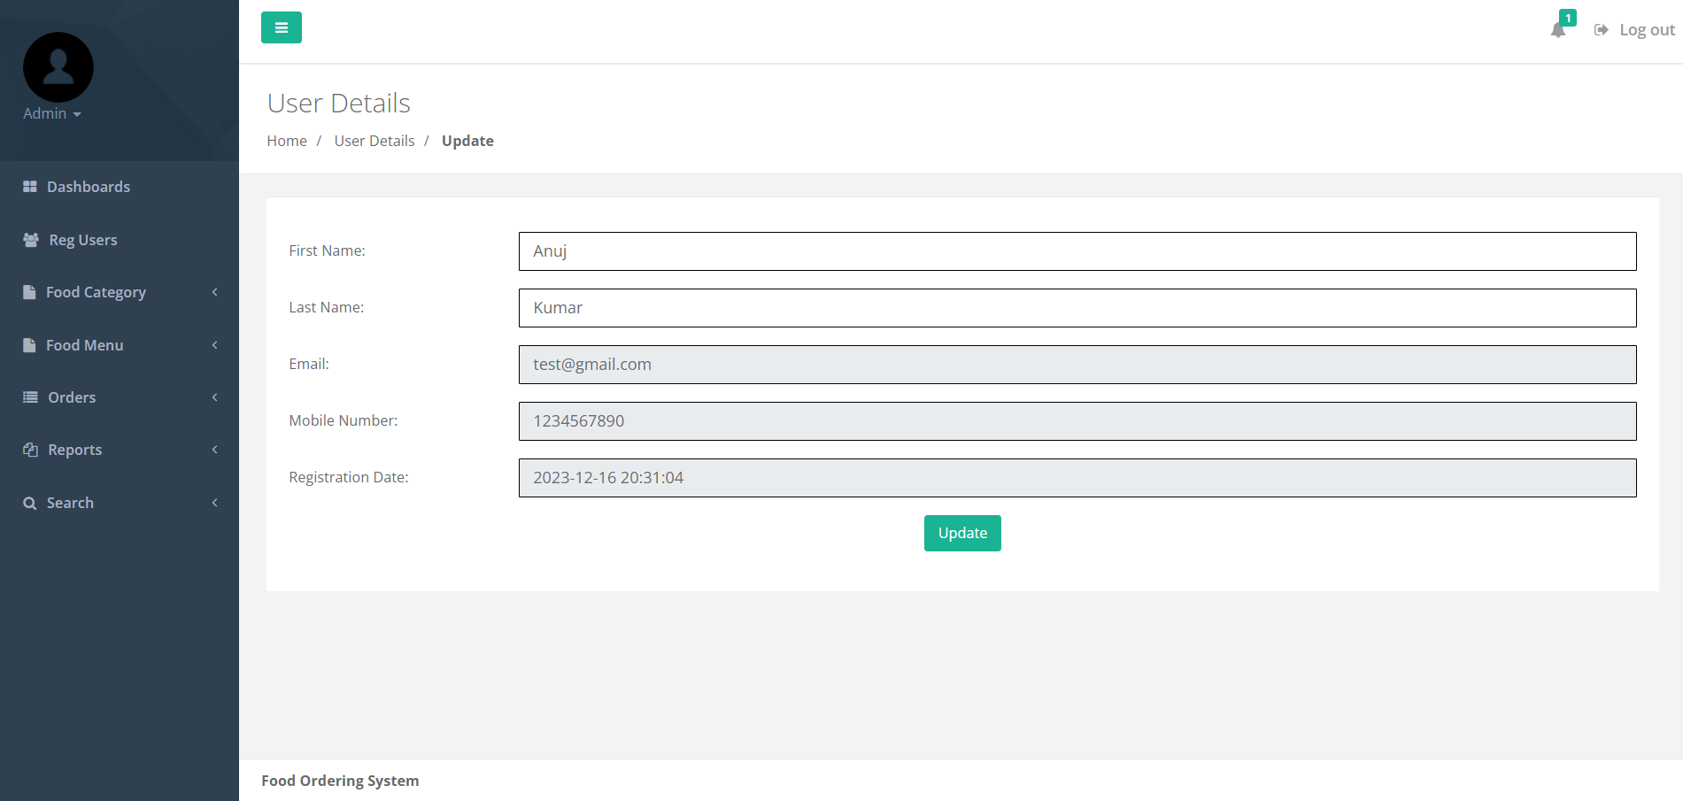

**Search Order**

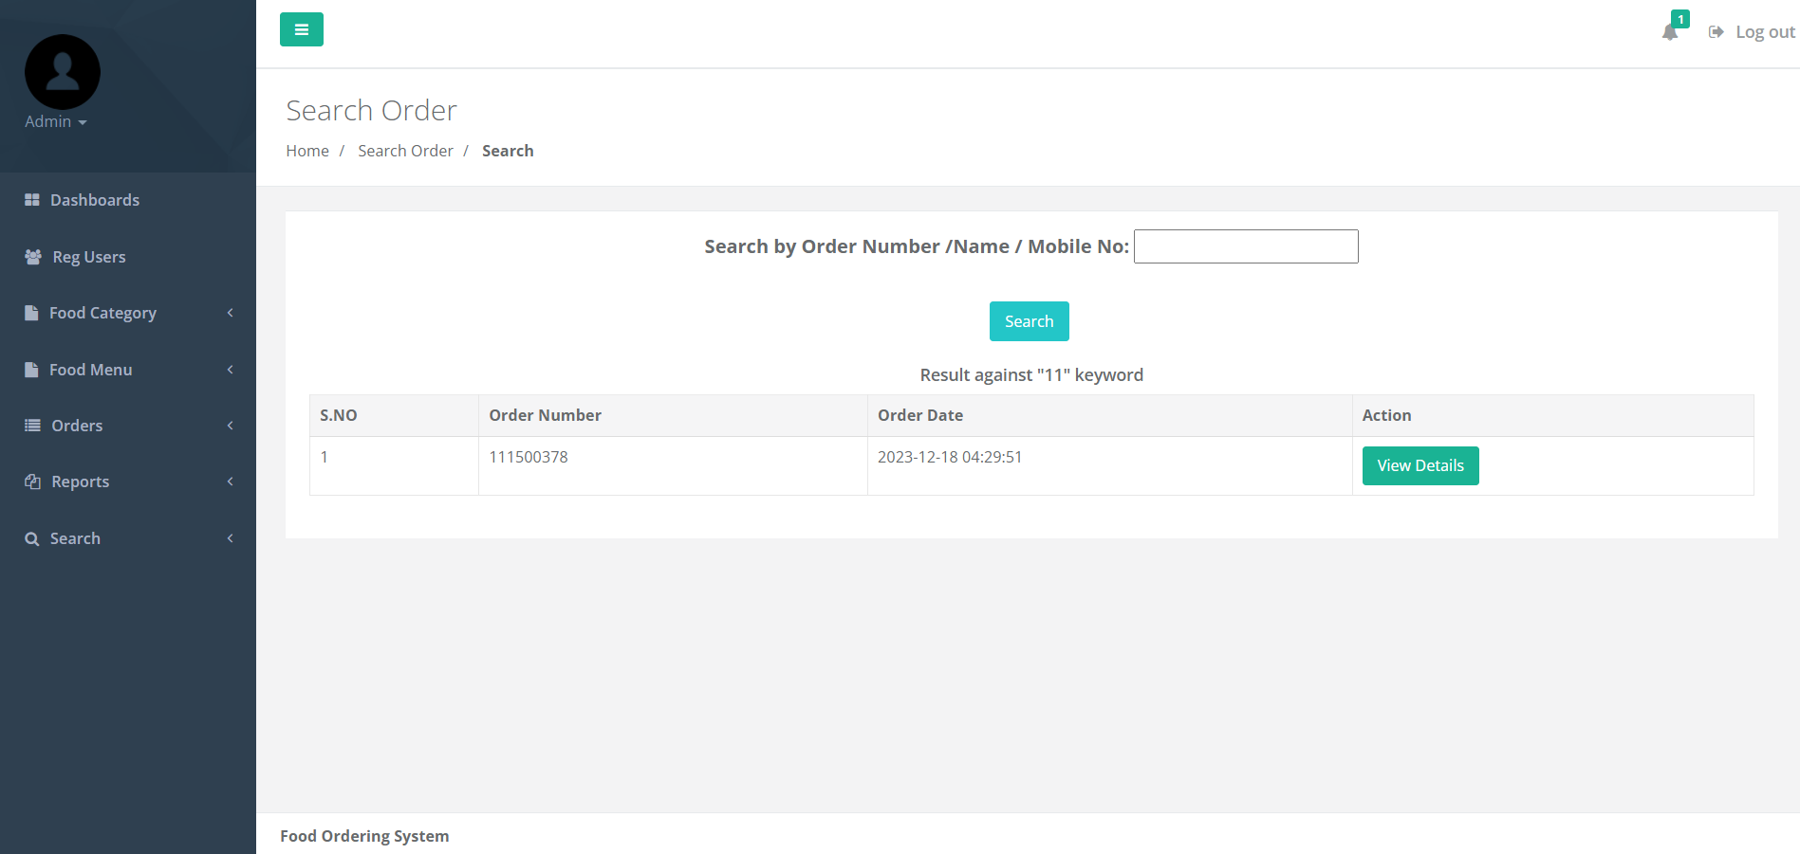

**Between Dates Reports**

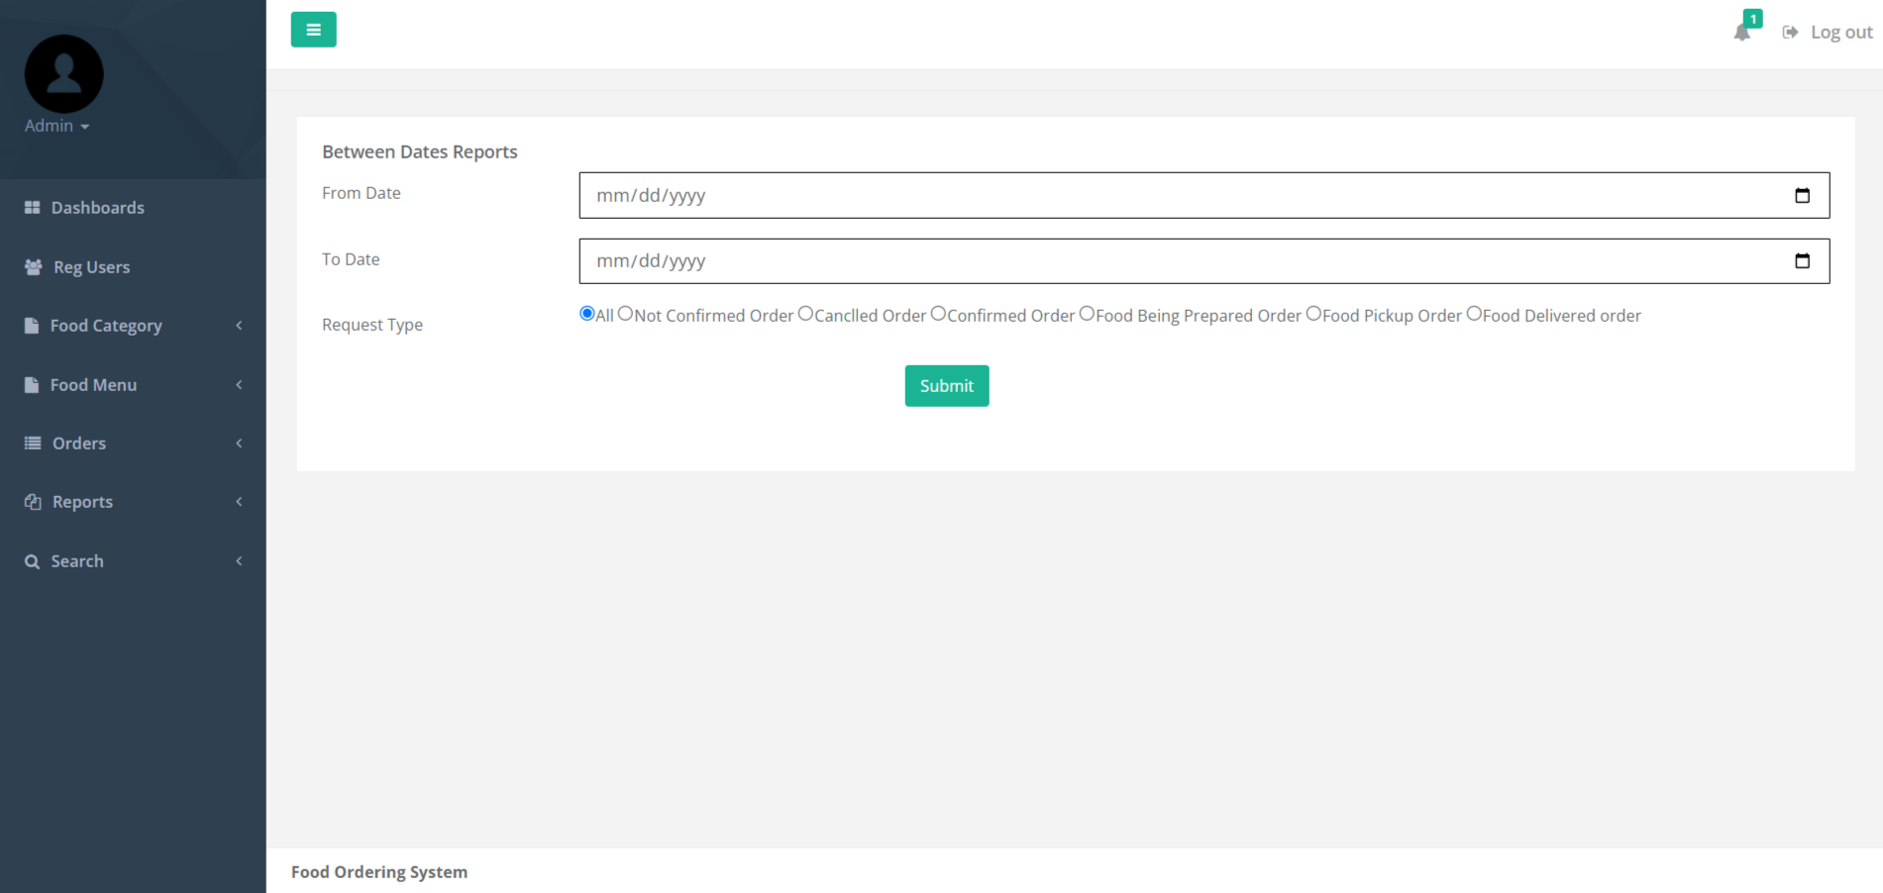

**Details of Between Date Reports**

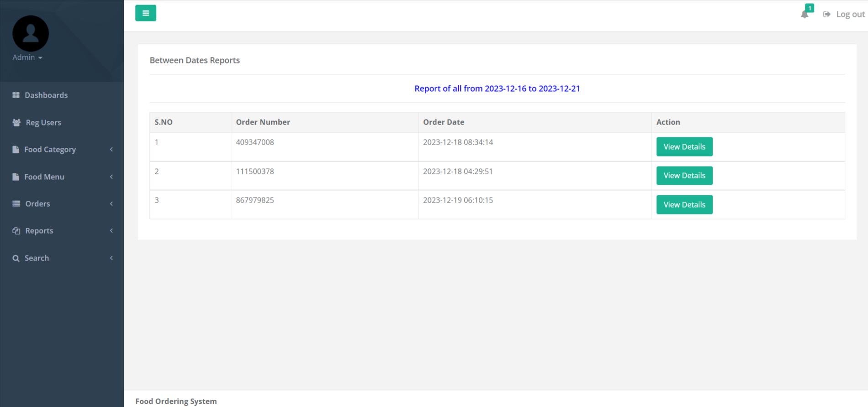

**Order Count Report**

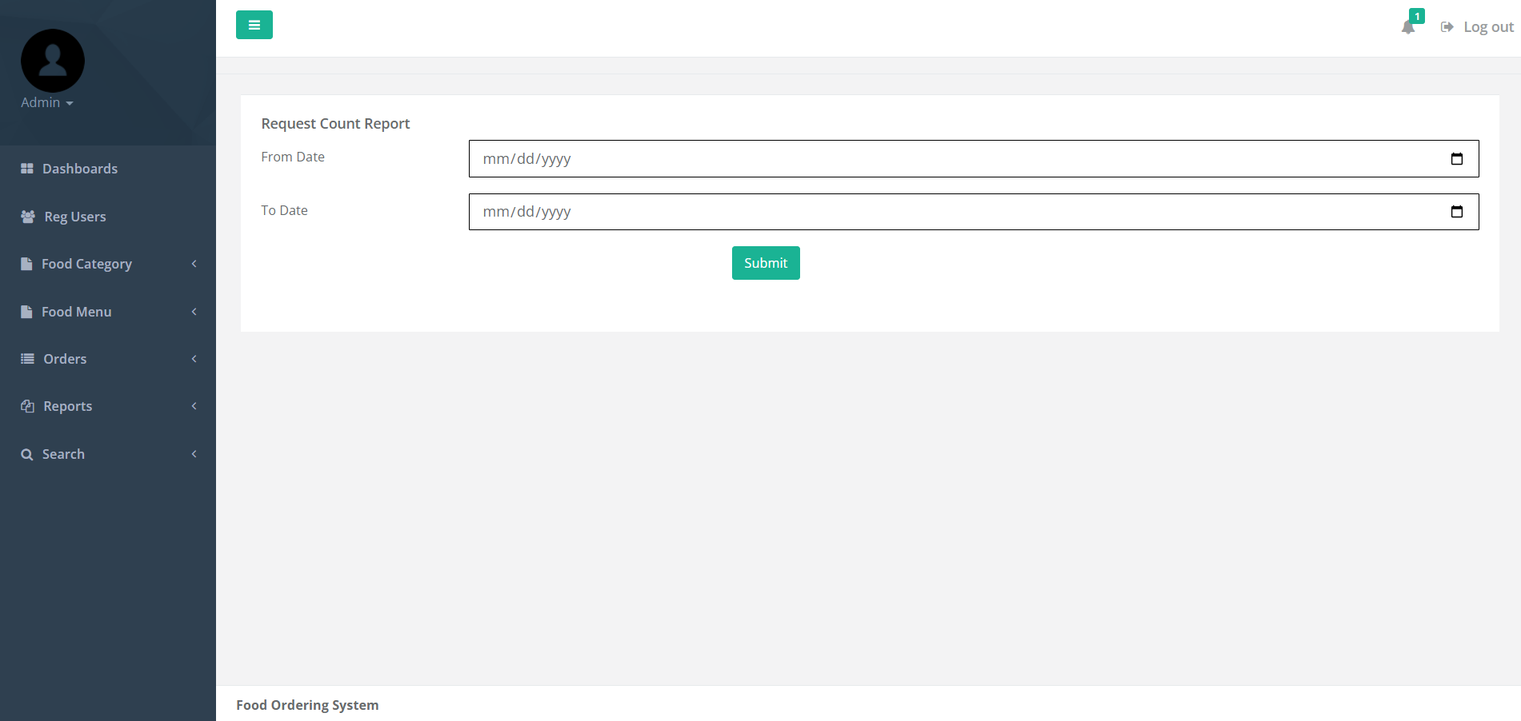

**View Details of Order Count Report**

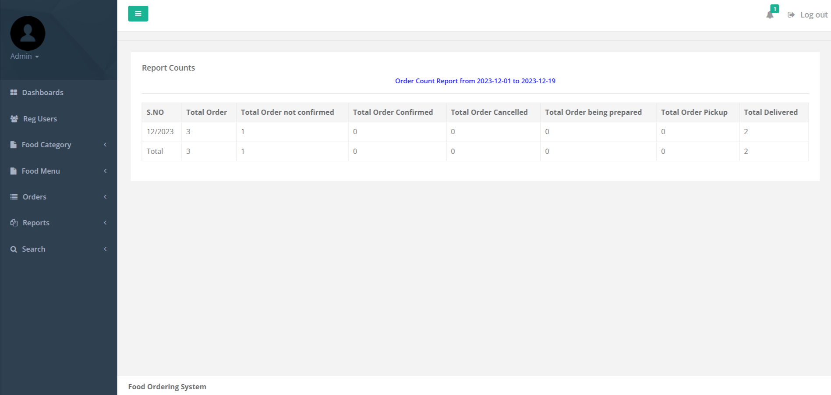

**Month wise Sale Report**

 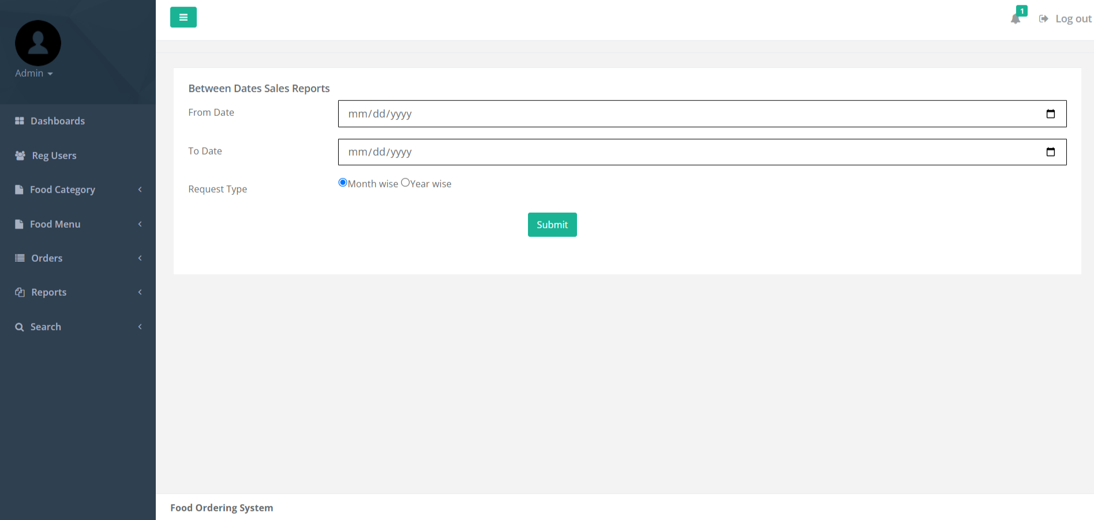

**Details Month wise Sale Report**

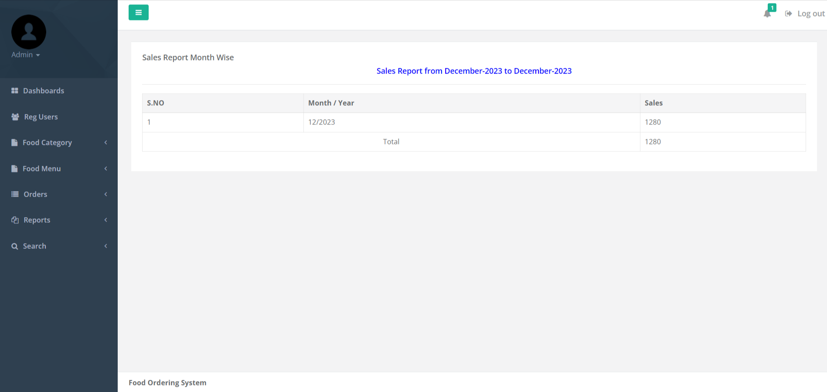

**CONCLUSION**

After a decade, the advancement and innovation of technology help people to manage their task easily and efficiently. In many other industry area have been used management system to assist their business grow long time ago, therefore it is also a trend that cause F&B industry to make use of a management system for their business. At the end of this project, the system can reduce and replace the human manpower task, reduce the time consume for each transaction and generate report for further management purpose by fully utilizing the system.

Obviously, the propose system can help improve the productivity of the restaurant and thus directly did an impact to the profitability of the restaurant. Furthermore, it can also help restaurant to reduce the cost of operation in term of manpower, because the system have already facilitate majority of the business process by using the system. Therefore, it is believed that the system can lead the restaurant’s business grow from time to time.

On the other hand, the technology nowadays allows the portability requirement easy to achieve. Therefore, portability has become one of the factor that have to take into consideration in the system development process. Because portability bring a lot of benefit to user while they using the system such as it provide convenience, accessibility, easy to communicate and etc. Hence, portability has done an impact to the social that everybody is much more preferable to complete their task with portable device.

In order to fulfill these all requirement, our proposed method is combined the food ordering system which is in mobile platform into the restaurant management system which is in computer platform. The integration of both features which develop a system that can let user to have an experience of portability which is user can process their food ordering through using their smart phone or tablet. Besides, restaurant manage their daily operation management through using the computer platform it is because computer have some other features such as it has a wider screen, other compatible system that can help to manage the restaurant and some other driver that needed to communicate with those necessary hardware.

**References**

**For PHP**

* <https://www.w3schools.com/php/default.asp>
* <https://www.sitepoint.com/php/>
* <https://www.php.net/>

**For MySQL**

* <https://www.mysql.com/>
* [http://www.mysqltutorial.org](http://www.mysqltutorial.org/)

**For XAMPP**

* <https://www.apachefriends.org/download.html>